Detour and Return: Reflections on Portable Pedagogy in Art and Design Education
Digger Nutter

Abstract
This reflective paper explores how performing pedagogic practice in public can transform understanding of that practice. Detour, a paired walking activity originally developed for interior design students, was re-enacted at the GLAD 2025 symposium through a double-voice presentation. One voice, pre-recorded, described the original project with confidence; the other, live and uncertain, responded in real-time. This act of sharing became an experiment in pedagogic translation, surfacing three tensions latent in the original work: balancing openness with structure, practising attentiveness rather than intervention, and recognising silence as a pedagogic response.
Through these moments of noticing, I develop three conceptual scaffolds: trust objects, rhythm, and relevance, that together articulate portable pedagogy, a way of understanding how the relational affordances of studio teaching might translate across disciplinary boundaries. The central insight is that practices do not transfer through replication but require translation; what needs to travel is not the specific activity but the principles that made it possible. Three scaffolds support this portability: trust objects that hold lightly (artefacts carrying pedagogic intention while enabling autonomy), rhythm as a subtle pedagogic structure (temporal design that shapes attention), and relevance understood as relational rather than imposed (a connection emerging between the activity and the learner's questions).
Rather than offering a replicable method, the paper proposes conceptual scaffolds for understanding how pedagogic practices might translate across contexts. Portable pedagogy asks not “will this work elsewhere?” but "what need for it for this to work elsewhere?”
Key Words: walking pedagogy, research-creation, performance as inquiry, studio pedagogy, pedagogic translation

Introduction:
I am on the top floor of Nottingham School of Art and Design (Figure 1). My voice fills the room, not just from where I stand but also from screens positioned around the studio, playing a recording that describes a walking project designed for interior design students (Nutter, 2024). The recorded voice plays confidently and clearly; I move through seated colleagues, placing folded zines into their hands. My live voice responds to the recorded, tentative and searching. Two versions of myself occupy the room.
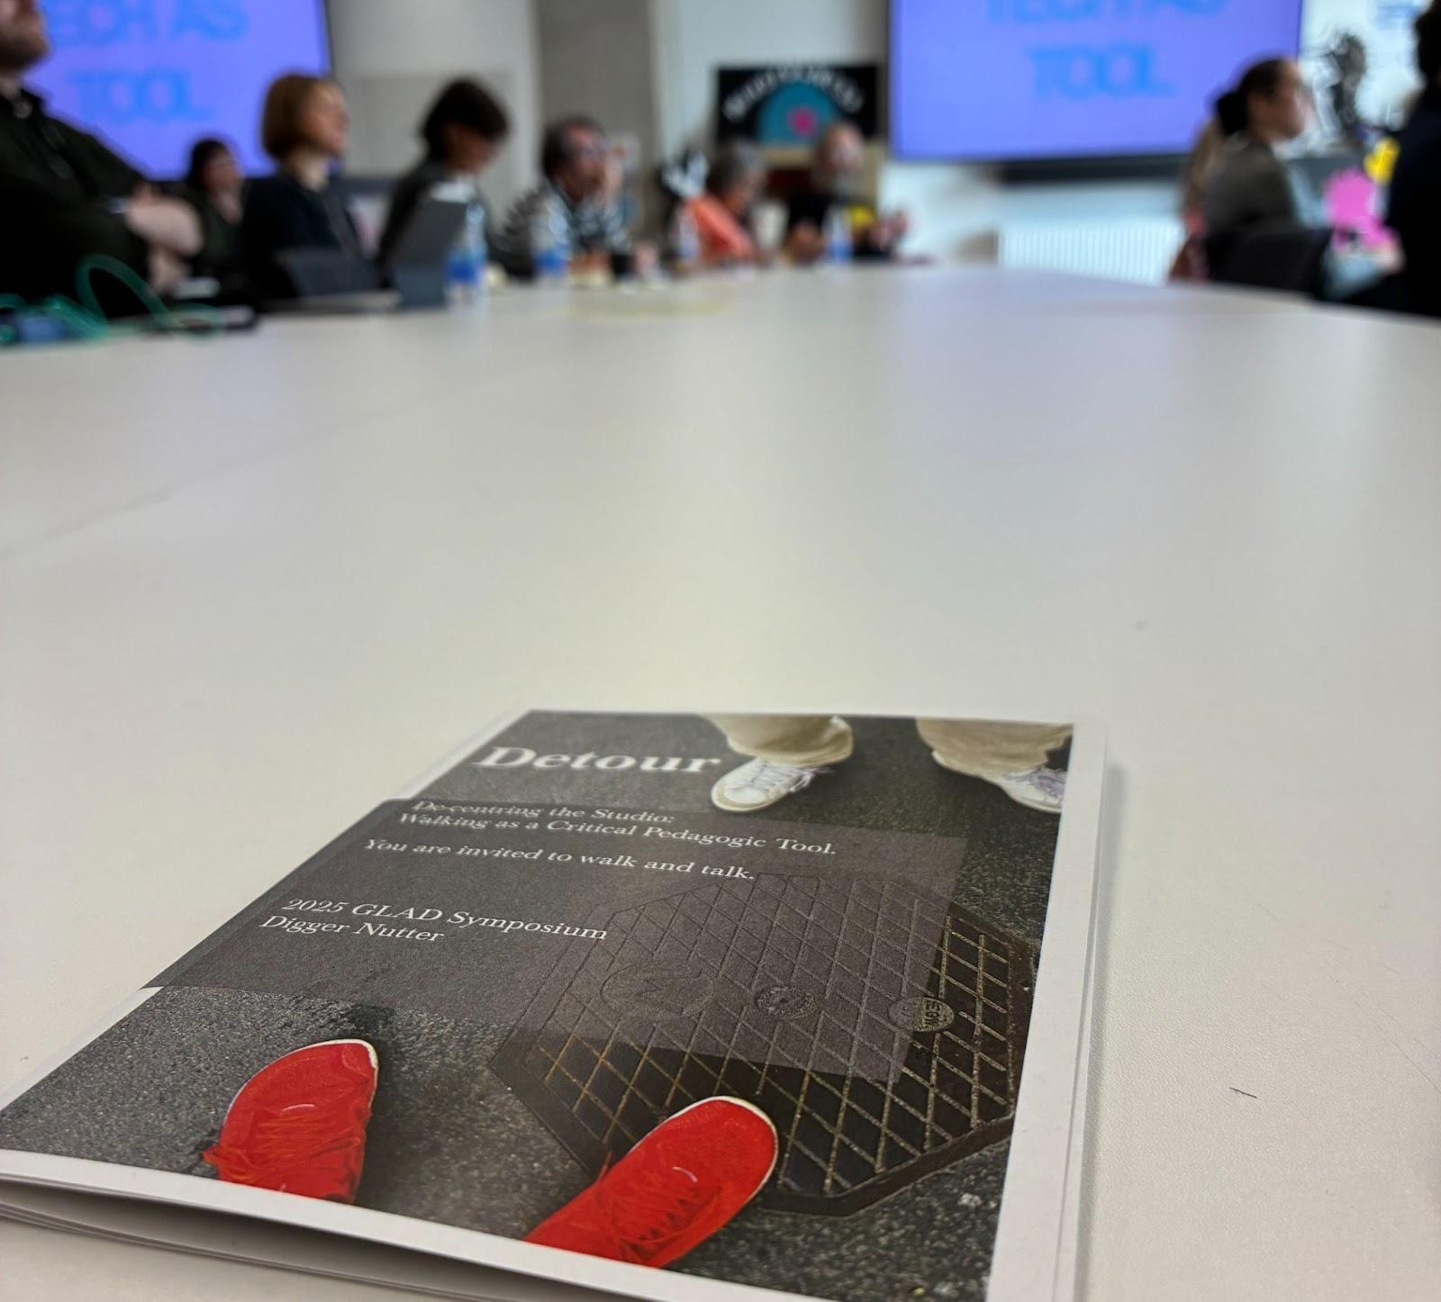
Figure 1. Distribution of zines during the GLAD 2025 performance.
This doubling was not just a presentation strategy. It was a way of testing the method. Both voices carried aspects of what I thought I knew about Detour—a pedagogic experiment where students walked in pairs through Glasgow, using a zine as a guide and prompt. However, in collaboration with myself in real-time and responding to the room, I discovered that I was not only presenting and reporting the work, but also continuing it, and noticing that practice reveals itself differently when performed in public.
What I discovered through this performance was not simply new insights about Detour, but a question about how studio teaching practices travel across contexts. This paper's contribution is conceptual: it develops portable pedagogy as a framework. Through autoethnographic reflective analysis of three tensions that surfaced at GLAD, I propose that studio practices depend on trust objects, rhythm, and relevance. Furthermore, I assert that all three must be rebuilt, not replicated, when practices cross boundaries. Presenting the work at GLAD became a way of testing whether its pedagogic logic could operate in a new context, making visible what this form of attentive practice depends upon to function. This mode of reflective inquiry has inherent limitations. Without shared responsibility or a shared curricular purpose, there is no obligation for participants to provide feedback, so I cannot know how colleagues received the work or whether they adapted it to their own contexts. This absence of participant voice highlights a methodological gap: we are no longer co-located and able to observe the changes or hear the echo of this work. I can interpret based on prior experience, but I acknowledge I have yet to hear the responses.
By presenting at GLAD and through the iterative reflection that followed, I identified three tensions, moments in which this walking practice revealed its dependencies. These tensions form the basis of portable pedagogy as a conceptual scaffold: they illuminate how studio practices depend on relational, temporal, and contextual conditions that don't simply transfer but must be reconstructed in each new setting. I trace each tension, showing how interpretive engagement with moments of uncertainty revealed the nature of pedagogic portability.
I trace three tensions:
- Openness and structure, how to invite participation without prescription, how to hold learning lightly.
- Attentiveness and intervention, recognising that walking pedagogy need not be disruptive to be transformative.
- Silence as a response, considering what it means when colleagues express interest but do not follow up, when invitations to engage are received quietly rather than loudly.
Through interpretive engagement with these tensions, I reveal what makes a detour in pedagogic practices transferable. My hope is less that you adopt this specific walking practice, rather that you try something new, one session where you let go of your signature pedagogy (Shulman, 2005) and embrace a small displacement. Feel free to borrow my model if it helps, or design your own detour. The value lies not in replicating my Detour but in your willingness to step aside, even briefly, from what feels secure.

Context: The Original Walk
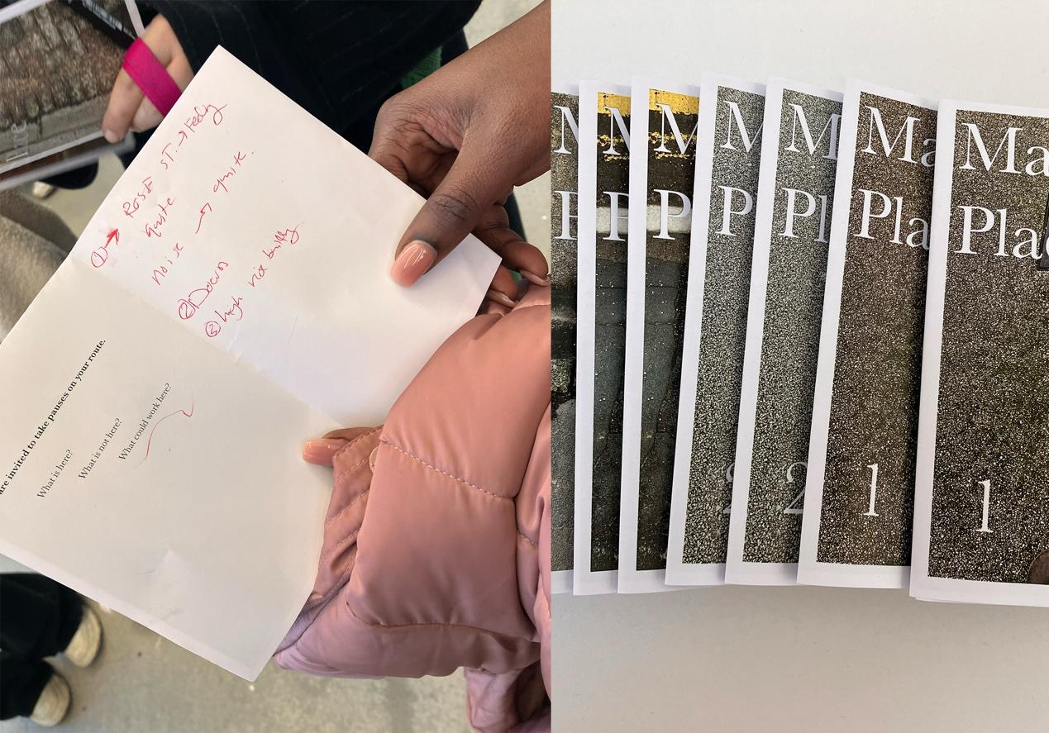
Figure 2: The Detour zine used by students during the original paired walks.
Detour began as a response to a practical need. I noticed that third-year interior design students who were about to select sites for self-directed projects had little embodied sense of Glasgow's urban fabric. While Yılmaz and Buldan (2025) demonstrate how situatedness in game-based learning can direct students toward prescribed collective memory embedded in place, Detour operates differently. Rather than guiding learners to discover historical narratives, it remains open to what the place might reveal and what learners bring to the encounter. situatedness as a generative condition rather than instructional content. In response to this observation, I designed two paired walking sessions, each structured by a folded zine offering destinations, discussion prompts, and invitations to notice and pause (Figure 2). The walks radiated outward from our studio in the city centre, each pair choosing their own route toward assigned locations marked on a shared map (Figure 3).
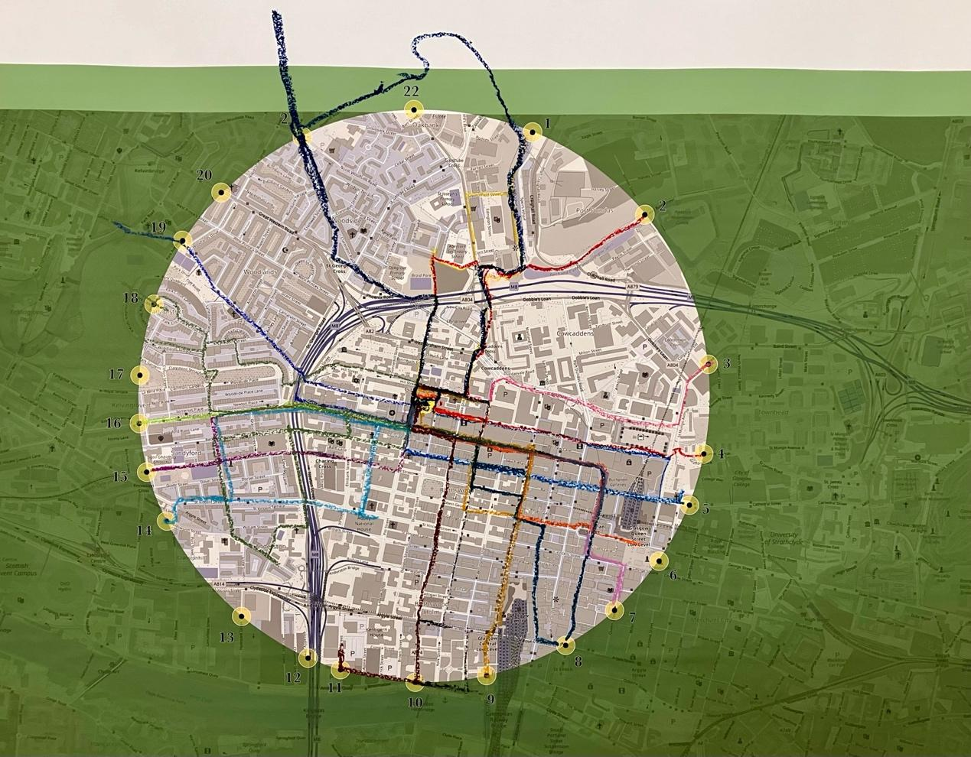
Figure 3: Copy of the map included in the zine and on the studio wall where walking pairs remapped their routes.
The design drew on collaborative learning principles, art walking practices, and musical scores. Particularly, Max Neuhaus's LISTEN (1966), which relocates the role of invitation into an artefact. In this case, enabling participation to unfold without my presence as the studio tutor. I also drew on the work of Janet Cardiff and George Bures Miller (1999, 2019), whose guided art walks skilfully integrate an imagined narrative that is overlaid onto the visual and acoustic journey the walker is guided through. Both of these works momentarily shift the viewer's perceptions, without providing any significant tangible signposts to non-participants.
Students walked in pairs, a deliberate choice, to enable side-by-side walking and talking (Kinney, 2017; Bilsland & Siebert, 2023). As they travelled, they navigated their own route and encountered questions like "What does this place invite?" and "Who might use this space?" The activity aimed to activate observation and foster site-contingent discussion, both during the walk and in subsequent studio work.
Student responses are detailed in the published study (Nutter, 2024) that revealed multiple modes of engagement. Some pairs fluidly transitioned between project-focused conversations and personal chats, while others described the walk as creating a distinctive type of learning—something that felt unfamiliar yet valuable. Many noted experiencing a delayed recognition, realising days or weeks later how the walk had influenced their site selection or design thinking. The structure of Detour purposefully activated what Lave and Wenger (1991) term legitimate peripheral participation. By pairing students and reducing my voice to prompts within a zine, I created conditions in which learning authority shifted from teacher to peer collaboration and from institutionally held to situated encounter. The city became a collaborator, allowing students to learned through proximity to place. This reorientation of pedagogic relationships allowed students autonomy to participate legitimately in practices of site reading and contextual exploration. The experience proved to be a successful studio intervention: students developed a richer contextual awareness and reported conversations that would not have occurred within a traditional studio setting.
At the time, I understood these outcomes as evidence of a successful intervention. What I had not yet considered was whether this success was context-specific or transferable, whether Detour's pedagogic logic could work beyond interior design, beyond Glasgow, beyond the specific conditions that had made it possible.
The study also surfaced tensions. Participation dropped significantly between Walk One (full attendance) and Walk Two (approximately 50%). Students described uncertainty about what they were meant to achieve, whether the activity "counted" as learning. The open-endedness that created space for discovery also generated ambiguity about value and purpose.
These tensions stayed with me. When invited to present at GLAD 2025, I saw an opportunity to test whether Detour could travel, whether its pedagogic logic made sense beyond the specific context of a site-selection brief. What emerged was not simply a presentation but a reframing.

Performance: GLAD as Method
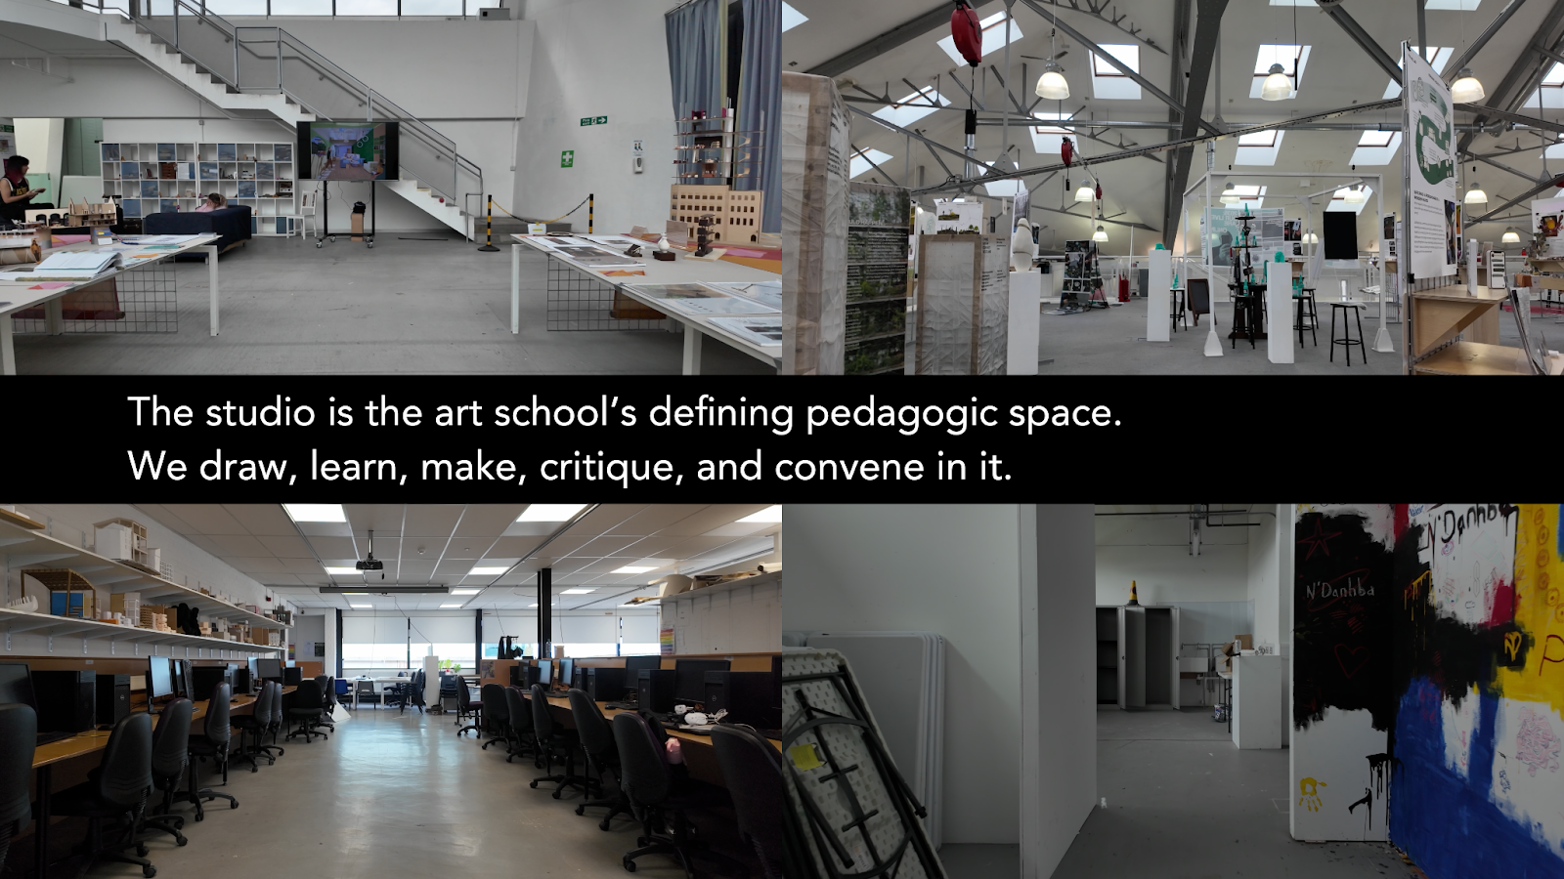
Figure 4. Still from the Detour film used in the doubled-voice presentation. The text was justified to the left, conveying my recorded voice, and to the right, live.
I presented Detour through a layered sonic architecture, a sonic rupture (Lacey, 2017). A pre-recorded narration played through a 7-minute film (Figures 4 & 5) that visually recorded the act of leaving a series of studios on the Glasgow School of Art campus. The studio space in Nottingham is not dissimilar to the spaces captured on the film played back on screens around the room. My voice conveys the original project with clarity and detachment, as though the work were complete and fully understood. While the recording played, I moved through the audience distributing zines, similar in form to the artefacts students had used. I filled in the gaps where the recording left off.
The live voice was different: present-tense, uncertain, responsive to the room. Where the recording described what happened, the live voice explored what it might mean. This doubling created a fragile choreography. While the conversation was scripted with both my recorded and live voice subtitled, my live voice sometimes agreed, sometimes questioned, and stumbled. The audience sat between these two voices, holding zines that invited them to walk but offered no immediate destination.
The performance highlighted Detour's core tension: between structure and openness, between trust and agency, and between invitation and imposition.
Audience responses during the session focused on practicality and transferability. Several colleagues considered how to adapt the approach for their respective contexts, disciplines, cities, and cohort sizes. Others were drawn to the zine as an artefact, curious about its design and the specific prompts it contained. A few asked directly whether I thought this could work outside the specific conditions of the interior design project, without an obvious anchor, such as site selection.
I found these questions difficult to answer in the moment. They assumed the work was finished, ready for replication. However, the performance itself was revealing, showing that Detour remained unfinished, not failed, but porous, still taking shape through each encounter. Some colleagues took zines and expressed an intention to try walking with their students. None reported back.
This silence initially disappointed me. I had framed the presentation as an invitation, offering the zine as a portable tool others might activate. When no one returned with stories of their own walks, I wondered whether the invitation had been too abstract, too disconnected from colleagues' immediate needs. But over time, the silence began to feel more complex, perhaps evidence of something working differently than I expected, operating on timescales and in ways not visible to me.
What shifted through GLAD was not the addition of new data but a reorientation of attention toward the question of portability itself. The performance became a test: could Detour's pedagogic structure hold without its original anchors? What would it reveal about translation versus replication?
As introduced earlier, through iterative reflective engagement, a set of tensions requires further exploration: how to maintain openness within a structured framework, how to practice attentiveness rather than intervention, and how to interpret silence as a form of pedagogical response. These are the sites for developing my thinking and testing assumptions that were latent in the original project.

Tension One: Openness and Structure

This tension emerged through the GLAD discussion: how to invite participation without prescription, how to hold learning lightly.

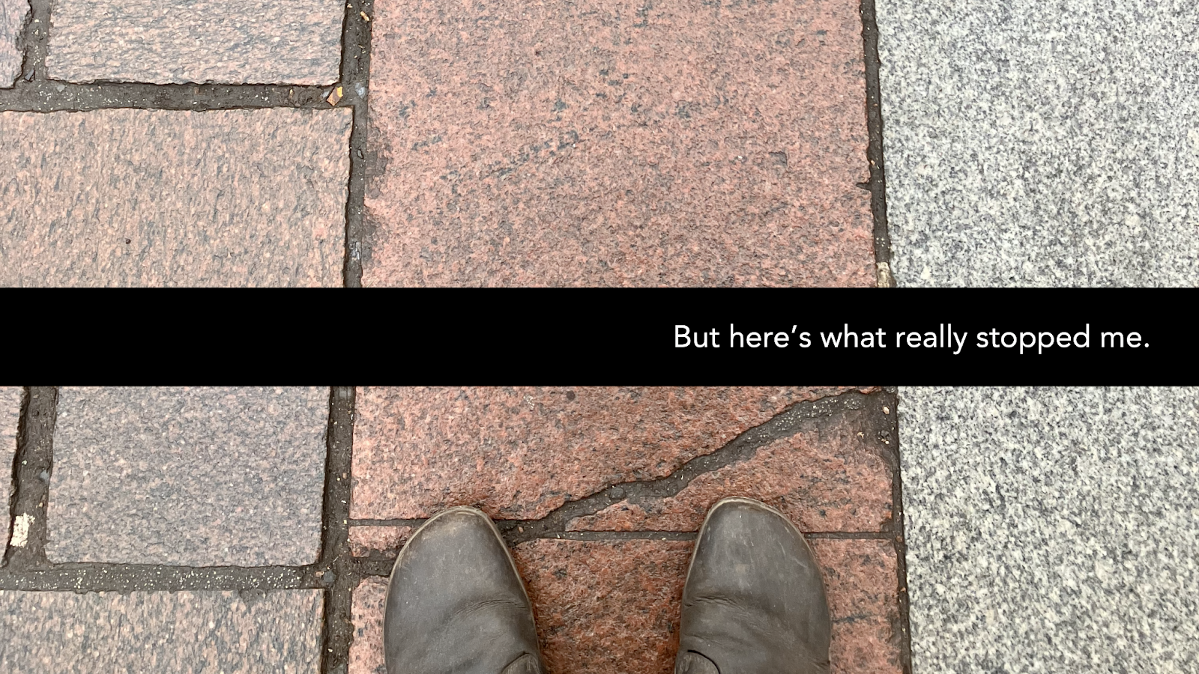
Figure 5. Still from the Detour film used in the doubled-voice presentation. Text justified to the right was my recorded voice.
When I designed the walking exercise for third-year interior design students, it responded to a practical need. The students were about to select sites for self-directed projects; however, the programme team and I were conscious that they had a limited embodied sense of Glasgow’s urban fabric. The paired walks offered both structure and invitation. Each pair received a folded zine containing a destination marked on a map, discussion prompts about place and use, and invitations to notice and pause along their route. Walks began and ended in the studio.
The structure was light but present. I had visited each destination beforehand, photographed it, and confirmed it was findable. The zine gave just enough direction: a marker on a map, a few open questions, permission to take detours. Students returned with richer observations, deeper contextual understanding, and stronger site selections. The activity worked (Nutter, 2024).
At GLAD, I offered the same invitation, a similar zine, the same open structure, but it landed differently (Figure 6). Colleagues were intrigued but hesitant. Without a shared project, without the trust built through weeks of collaborative studio work, the openness felt abstract rather than generative.
This clarified something I had recognised but not fully explored in the original project. There is more to the success of walking activities than the act of walking itself. The scaffolding, the surrounding structures of trust, purpose, and relationship. Pleschová et al. (2025) building on the work of Schilke, Reimann, & Cook (2021) describe "objects of trust" as artefacts that carry pedagogic intention, allowing learners to engage autonomously while feeling held. The zine functioned this way for students because it arrived within a context that gave it meaning. For colleagues at GLAD, the zine was an interesting artefact but not yet a trusted object. It had no relational anchor.
In listening to feedback from colleagues, I heard concerns about the openness of the invitation and the zine within the context I had presented. My immediate response was that the work reveals its intentionality through engagement with the process. Not through control or prescription, but a kind of care that creates conditions for autonomous engagement. However, this does not fully address the concern and omits the recognition of the credibility of the trust objects (Pleschová et al., 2025). In the student project, this trust was distributed across multiple elements: the zine as a material guide, my presence as a tutor, the project brief as a purpose, our prior relationship as a foundation, and the ethical frame of research participation. Each element worked together to make the open-endedness feel generative rather than adrift.
At GLAD, I had only some of these elements. The rhythm of my recorded voice provided temporal structure. The physical act of distributing zines created a momentary connection. The performance itself modelled a way of being uncertain together. However, without a shared purpose or an ongoing relationship, these gestures could only suggest, rather than establish trust.
Returning to this question of openness after GLAD, I found Friedman, Morrison, and Rickards's (2025) description of walking pedagogy as a practice that "accommodates trauma and adapts practice" particularly illuminating, situated primarily in nature-based school contexts. They recognise that not all bodies move in the same way and that not all learners require the same level of support. Crucially, they emphasise that inclusion necessitates careful attention to how openness is maintained. If openness is too loose, participation can become overwhelming or meaningless; if it is too rigid, it can stifle the very discoveries it seeks to promote.
This balance is what I have come to think of as managed openness, a form of structured ambiguity that gives learners orientation without prescribing direction (Jones et al., 2025). Students know how the session will unfold the temporal spine, the purpose, the framing, but not what must be concluded or said. This enables uncertainty to be encountered rather than defended against. Furthermore, it asks: What does this group need to feel secure? What structures enable rather than constrain? When does guidance become a prescription? The zine worked for students because it calibrated openness to their specific context: just enough direction to reduce anxiety, just enough freedom to allow discovery, and a signpost that I had been to the location they were invited to find. At GLAD, the same artefact lost its context, so it needed different scaffolding. Perhaps a clearer invitation to try it within their own teaching, explicit permission to adapt rather than replicate, or a follow-up that this paper might provide, could sustain the invitation beyond a single encounter.
What I learned is that trust objects are not universally portable. They gain their holding power through relations (Mori, 2025). The zine is not inherently a trust object; it becomes one when it arrives in a context where learners recognise someone has designed it with care for their particular situation. Detour works when its openness is calibrated to the ground from which participants begin, including their questions, fears, curiosities, and constraints. This is difficult to achieve in a conference presentation. The encounter is brief, the relationships are new, and the purposes are diverse. Yet this is precisely what makes such moments valuable for reflection. They reveal what had been invisible in more familiar contexts. This is the first principle of portable pedagogy: context-dependence is not a limitation but a design feature. What makes a practice portable is not stripping away context but understanding which elements must be rebuilt in each new setting.
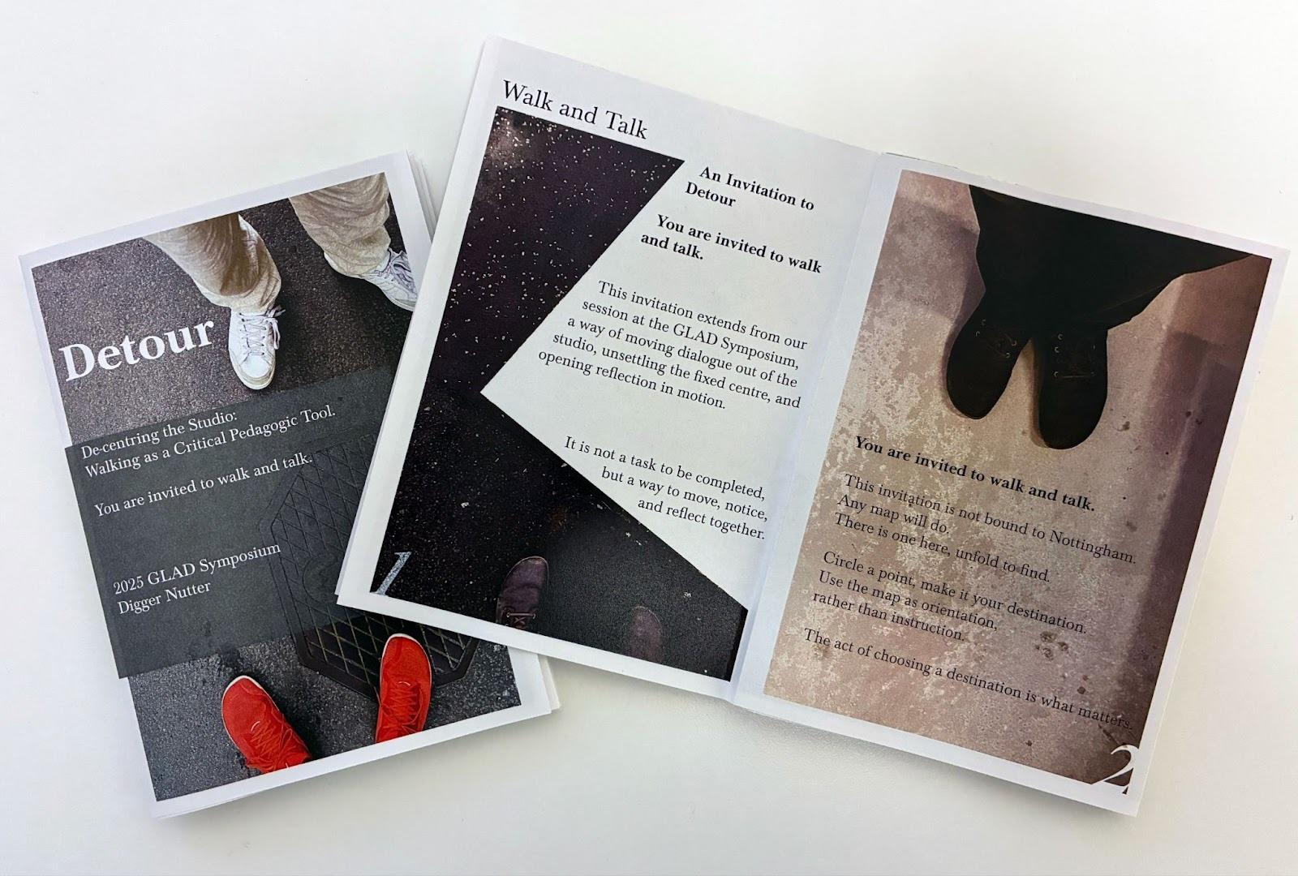
Figure 6: The Zine prepared and shared for the GLAD symposium.

Tension Two: Attentiveness and Intervention
This tension developed through conversation after the presentation, building on comments from colleagues both within and beyond the symposium: recognising that walking pedagogy need not be disruptive to be transformative.
Walking pedagogies within art schools are often framed through activism, ways to intervene in space, disrupt institutional norms, critique urban planning, and make visible what is overlooked. This tradition has an important lineage, including the Situationist dérive, psychogeographical mapping, protest walks, and performances that remake public space (Gros, 2015; Careri, 2017). Detour shares some of this lineage. It asks students to move through the city with heightened awareness, to notice what is usually overlooked. But it seeks something quieter than intervention. Its purpose is not to alter the environment but to dwell within it, allowing learning to arise through sustained attention (Ingold, 1993; Gros, 2015; Miles & Libersat, 2016).
During the original walks, this became evident in how students described their experience. Conversations slowed. Silences lengthened. Buildings they had passed daily for months suddenly became specific, not just "that building" but a particular contrast to the normal, or an unexpected place of pause. One student described it as "seeing Glasgow anew", exploring a place she thought she knew, and noting new details. Another described how the walk made her feel less like she was gathering information and more like she was gaining an understanding of the places she walked through.
This suggests a different relationship to knowledge-making, one rooted in proximity and presence rather than analysis and judgment. Students were not intervening in Glasgow or imposing their design ideas onto sites. They were learning to be with places long enough for those places to reveal something.
At GLAD, I became aware of how unusual this stance is within art school contexts. Several colleagues assumed Detour was about creative intervention, that students would perform, photograph, or somehow mark the spaces they visited. One asked whether students created site-specific work during the walk. Another wondered if they were meant to critique what they found, identifying problems that required design solutions.
These are reasonable assumptions. Art and design education often positions students as change-makers, problem-solvers, and creative disruptors. Walking becomes a way to gather material for intervention elsewhere (Batic, 2011). However, this position frames the walk as a resource, a site for extraction or improvement, and assumes an intention to act upon rather than learn from it.
Detour initiates something different: that the work of walking side by side promotes learning to be in company with another and the place. Not passive observation, it requires active attention, choosing where to linger, what to trace with your eye, and when to pause. Furthermore, it prioritises the conditions of encounter over the production of outcomes. It asks students to hold their design ambitions lightly enough to let places speak first. This distinction matters pedagogically and ethically. In the studio, attentiveness is often overshadowed by interpretation, judgment, critique—all the moves that assert the designer's agency over what is being designed. These moves have value, but when they dominate, they can foreclose listening (Jones et al., 2025, p. 259-288). To practice attentiveness is to delay those moves long enough to let complexity emerge.
Drawing on Revell & Sarah’s (2024) exploration of radical and embodied listening through a feminist lens, I was particularly drawn to Gray's (2024) discussion of attention as a receptive practice that creates space for what cannot yet be named. Gray describes how listening involves not just hearing but also a willingness to be changed by what is heard. Applied to walking and side-by-side conversation (Kinney, 2017), this suggests that walking in places might teach us something if we can resist the urge to categorise, judge, or redesign what we encounter immediately.
This is challenging for design students, who are encouraged to see problems and imagine solutions (Orr & Shreeve, 2018). Several students in the original project expressed frustration during the first walk. They expected to be measuring buildings, sketching details, and identifying design failures. The prompts in the zine redirected them toward observation: What does this place invite? Who moves through here and how? Where does your attention go? These questions do not ask for a design response. They ask for sustained noticing. In the discussion, students described this shift as valuable. One reflected that she usually walks through Glasgow "on the way to somewhere else" and that the enforced slowness made her realise how much she misses. Another said the walk helped her understand that selecting a site means understanding what it already is before imagining what it might become.
This is not about romanticising place or avoiding critical analysis. It is about sequencing—attending before intervening, listening before speaking. In pedagogic terms, it suggests that we might sometimes hold back our expertise, our quick readings, our design solutions, to create space for different kinds of knowing to emerge (Ingold, 2015).
At GLAD, this raised questions I am still thinking through. If walking pedagogy is not about intervention, what is its radical potential? Can attentiveness alone be transformative, or does it risk becoming complacent? I do not have resolved answers. But I notice that students who spent time attending to Glasgow's places without immediately trying to improve them often made more thoughtful design proposals later. Their interventions, when they came, seemed to emerge from rather than impose upon the sites they had chosen. Perhaps this is what attentiveness offers: not the absence of change but change that begins from genuine encounter. This is the second principle of portable pedagogy: the stance matters as much as the structure. Detour travels not as a set of instructions but as an orientation, a way of being with places and with learners that prioritises attention before intervention.

Tension Three: Silence as Response
This tension echoed a challenge held within the original student project, and through absence in the weeks that followed the symposium, revealed the third tension: what might silence mean as a pedagogic response?
Several colleagues expressed enthusiasm about trying the zine or adapting the method for their contexts. They asked thoughtful questions about timing, pairing strategies, and how to frame the invitation to students. A few took zines with them, saying they would experiment with them. Yet, although invited, none reported back.
At first, this felt like disappointment, an unfinished loop of exchange, a missing part of an evaluation cycle. I had framed the GLAD presentation as an invitation, offering the zine as a portable tool others might activate. When no one returned with stories of their own walks I wondered whether the invitation had been too abstract or too disconnected from immediate needs. Perhaps colleagues were simply busy. Perhaps the idea intrigued them, but it didn't quite land. Perhaps they tried it, and it did not work.
But over time, the silence began to feel more complex. Perhaps the invitation had landed but privately. Perhaps it prompted reflection rather than replication. In art and design education, silence often carries meaning we learn to read (Cage, 1961; hooks, 1994; Alerby, 2019). The pause in a crit when something resonates too deeply for immediate language. The student who says nothing during the session but returns weeks later with work that shows they were listening (Nutter, 2025).
Still, the quiet that followed GLAD revealed something structural rather than simply affective. In the original studio-based work, engagement was sustained through relevance, shared trust, and proximity. Students knew why they were walking as the activity was linked to their project, and crucially, the durational setting allowed for the return of echoes. Responses returned indirectly through subsequent conversations, design decisions, shifts in language, and changes in how they framed their work. Even when participation was partial or delayed, the studio provided opportunities for responses to be heard over time.

At the conference, those conditions were absent. Without a defined purpose, shared context, or relational contract, participation relied entirely on individual curiosity. More significantly, the participants and I left the site of the invitation. Drawing on Amit Pinchevski's Echo: Across Nature and Culture (2022), an echo requires not just an initial sound but conditions for its return. Here, the walk was offered, but there was no shared space in which its effects might be made visible. Silence, in this context, cannot be read as disengagement, but neither can it be interpreted with confidence. By inviting participants to engage in their own way and at their own pace, with no fixed structure or requirement to return or provide feedback, I relinquished access to insight.

This absence mirrors earlier student responses within the project, where around half did not return for the second walk and where several only articulated the value of the first walk much later. In the studio, that delayed recognition was still available through shared space and time; at GLAD, it remained unheard. An invitation that hands over authority and agency to participants is a strength of the approach, but it also exposes a methodological fragility: when the site of invitation is transient, the analytic loop is not simply left open; it becomes untraceable. The echo, if it exists, is beyond my auditory horizon.

What I had framed as an invitation may have needed clearer thresholds, ways for others to imagine the value before committing time. Or perhaps it needed ongoing contact rather than a single encounter. The students' engagement with Detour did not happen all at once. It unfolded across two walks, studio discussions, individual conversations, weeks of project work. Pedagogic practices embed themselves slowly, through repetition and relationship. A conference presentation offers neither.
This reframed my understanding of Detour's temporality. Its outcomes are not always immediate or visible. Students themselves described "delayed recognition", realising days or weeks later how the walk had shaped their thinking. One student wrote in reflection that she did not understand the value of the walk until she was sitting with the drawings of her chosen building weeks later and remembered a question from the zine.
If learning works this way—quietly, latently, over time—then silence might not signal failure. It might signal that something is working differently than expected, on timescales not visible to me, in forms not reportable back. This requires a different relationship to pedagogic evidence.
However, I also recognise that silence can result from insufficient scaffolding. Colleagues who expressed interest may have genuinely wanted to try Detour but lacked the anchors that would make it feel possible: connection to their curriculum, time to design their own version, or confidence that it would work in their context. What I experienced as their silence might have been my failure to build adequate support.
To accept silence as a response is to acknowledge that pedagogic attention does not always fold back. It leaves me attentive to how silence might be held, while also appreciating and understanding it as constructive (Alerby, 2019). The walk I designed for students worked because it arrived within a strong relational and curricular intent, a situated context that allowed me to read the silence I experienced in their remote conversations. Salazar (2025) argues that situatedness describes "the dependence of meaning and identity on particular geopolitical and sociocultural contexts." (Salazar, 2015, p. 15) Detour in Glasgow was deeply situated, embedded within a program rooted in Glasgow's urban fabric, with students who belonged, if only presently, to that place, suggesting that situatedness is possible precisely because of existing rootedness. At GLAD, this foundation was absent, thus. What I experienced as silence may have been the consequence of offering a practice severed from its necessary situatedness, a walking pedagogy without a place to walk from.
This does not mean the sharing failed. It means it worked differently—offering ideas that might surface later, for some people, in forms I will not see. This is the third principle of portable pedagogy: outcomes may be invisible to the teacher. When practices travel, they operate on timescales and in forms we cannot track. Portability requires accepting that we may never know how, or whether, our invitations land.

Three Scaffolds of Portable Pedagogy
These three tensions, openness and structure, attentiveness and intervention, and silence as response, form the conceptual foundation of portable pedagogy. They reveal both what prevented Detour from travelling smoothly to GLAD and what might enable or prevent pedagogic translation more broadly. Through sustained analysis of these tensions, three conceptual scaffolds emerge that, together, articulate portable pedagogy: trust objects, rhythm, and relevance. Rather than prescriptive methods, these scaffolds offer a lens for understanding the conditions under which pedagogical potability depends.
However, they suggest something beyond this individual act of teaching and point to approaches to making studio pedagogy more portable. How might we recognise the subtle differences in our collective signature pedagogy (Shulman, 2005; Klebesadel & Kornetsky, 2008; Orr & Shreeve 2018) and notice what works in one context and how it might travel to another without losing what makes it work.
The core insight is this: practices do not transfer through replication. They require translation. This observation is not new, yet studio pedagogy often operates at a disciplinary or sectoral scale—Fine Art studios differ from Design studios differ from Architecture studios. Movement across these boundaries remains rare and difficult.
Smart, Cleaver, and Robertson's (2020) work on intangible assets offers a useful framework, though it needs adjusting for this context. They propose micro (individual/team), meso (department/school), and macro (whole institution) scales for understanding impact. For studio pedagogy, I propose a different mapping: micro encompasses programs and schools where disciplinary identity is strong; macro operates across institutions through sector-wide initiatives. This leaves meso as the overlooked but critical space, the intersections and overlaps between disciplines, the places where translation might happen but often does not. It is precisely this meso scale that remains an opportunity for further exploration in Detour as a methodology. While presenting at GLAD, this dialogue was initiated, but it remains underexplored. Furthermore, Smart, Cleaver, and Robertson's naming of the values created and sought as intangible assets, along with the proposed framing, directly links to the mode of Detour and could provide a helpful lens for better understanding the value created, whether intended or experienced.
With this intention to explore permeable practices at a meso, cross-disciplinary level, it is important to consider that what needs to travel is not the specific walk but the principles that made the walk possible.
I have come to think of these principles as scaffolds for portable pedagogy, not blueprints for replication, but rather structures that support translation. Each scaffold addresses one of the tensions revealed at GLAD, offering a way of thinking about how relational teaching practices might adapt to new contexts while retaining their pedagogic integrity. Ways to design moments where familiar pedagogic routines might be gently interrupted, to see what else becomes possible. Three scaffolds emerge from this reflection.
First: Balancing openness and structure needs trust. I assumed that the zine functioned as what Pleschová et al. (2025) call an object of trust, an artefact carrying pedagogic intention, enabling autonomous participation while creating a sense of being. However, this trust object only truly existed in the context of my teaching practice, recognising that trust objects are not inherently portable. A similar zine meant different things to students within a project than to colleagues at a conference.
What matters is not the specific artefact but the principle, offering something tangible that carries care. This might be a zine, a question card, an audio prompt, or a shared map. The object should be simple enough to grasp quickly, open enough to allow interpretation, and carefully enough designed to signal that someone has thought about the participant's experience. It should feel like an invitation, not an instruction.
In your context, this might mean: What could you make that would hold your pedagogic intention when you are not present? Not to replace you, but to extend the invitation beyond the moments when you are available.
Second: That timing of the appropriate invitation is key, highlighting rhythm as pedagogic structure. One thing that surprised me in both the student walks and the GLAD performance was how much rhythm mattered. The duration of walks, the pacing of prompts, the tempo of conversation, the punctuation of arrival at a destination, these temporal structures shaped what could be noticed and learned.
Rhythm is often invisible in teaching. We think about content, activities, and assessment, but less often about tempo. Yet both students who participated and colleagues who commented described the walk's value partly through its temporal quality. They recognised the enforced slowness, the permission to linger, the way conversation moved as tangible and valuable. To design pedagogically with rhythm means asking: What pace does this moment require? When should students move quickly, and when should they move slowly? When do we want to explore sustained attention, and when do we move to intentional intervention, student-designed, or teacher-guided?
In your context, this might mean: Take one session and change only its tempo. Keep the same content but rearrange its pacing. Add a long pause. Ask students to spend twenty minutes with a single question before discussing. Or compress something usually stretched out. Notice what the rhythm change makes possible.
Third: Relevance is relational, not imposed. The clearest difference between the student walks and GLAD was the relevance of the former. Students knew immediately why they were walking—it connected to their project, their site selection, and their ongoing work. Colleagues at GLAD had to imagine relevance for themselves. Some could, some could not, and without that connection, the invitation remained abstract.
This reinforced to me that relevance cannot be assumed or asserted. It emerges between the activity and the learner's questions, between the invitation and the moment it arrives, between what is offered and what is needed. In sharing this work, the walking activity was not inherently relevant. Furthermore, relevance may also be delayed; an invitation received in one moment might only become meaningful later, in conditions beyond observation. The echo, if it returns, may do so beyond our hearing.
This is difficult for portable pedagogy because you cannot always know what someone else's students care about, what their pressing questions are, or what would feel relevant to them right now. But you can design with space for learners to locate themselves, and provide time and means to understand the engagement and responses.
In your context, this might mean: Before introducing a new activity, ask students what they are currently struggling with, then explicitly connect the activity to what they have identified, or invite them to make the connection themselves. If they cannot find relevance, that is useful information as perhaps the activity belongs elsewhere, or perhaps it needs to be framed differently.
These three conceptual scaffolds—trust objects, rhythm, relevance—are not prescriptions. They serve as starting points for considering how to design small pedagogical detours in your own context. The goal is not to replicate Detour but to find your own version.
This might look nothing like walking. It might be a different kind of pairing, a new way of using your studio space, an artefact you design for students to use without you. What matters is the willingness to displace yourself slightly, to create conditions where students might notice differently, attend to something usually overlooked, and find their own path through.
Together, these three scaffolds, trust objects, rhythm, and relevance. constitute what I mean by portable pedagogy: practices that acknowledge their dependence on context while remaining open to translation. The question portable pedagogy asks is not 'will this work elsewhere?' but 'what needs to be rebuilt for this to work elsewhere?
Start small. Try once. Notice what happens. Let that inform the next iteration. Pedagogic practices do not need to be revolutionary to be transformative; sometimes, the smallest displacement can reorient how learning feels.

Conclusion: Still Walking
This inquiry offers a way to test and understand the challenges of translating pedagogies across subtly different contexts. Rather than proposing a method, it asserts that when translating and relocating pedagogical approaches, careful consideration of the conditions and possibilities present is necessary. Though an exploration of three tensions that test the situatedness of learning, which emerged from presenting Detour at GLAD, this paper builds on and tests the roles of: trust objects that gain meaning through relationships; rhythm that structures attention; and relevance that emerges between learner and place rather than being imposed. Together, these scaffolds articulate portable pedagogy not as a solution to be replicated, but as a conceptual frame for understanding how pedagogies travel, deform, and reassemble across contexts.
Detour began as a practical response to a curricular need and has evolved through sharing into an inquiry about portable pedagogy itself, how studio teaching practices might travel across disciplinary boundaries, what they carry with them, and what they require to work in new contexts. Becoming a way of thinking about how studio pedagogies might loosen their anchor. At a moment when signature pedagogies (Shulman, 2005) are under pressure from institutional, cultural, and ethical directions, Detour becomes a small but deliberate interruption, a way to test what our habitual practices enable, and what they constrain.
The three tensions traced in this paper are places that keep the work open, preventing it from settling too quickly into a method or a model. While initially I thought this offered a replicable practice, with hindsight, I present this more as an invitation to try your own displacement. Let go of your signature pedagogy for one session and test the link between teaching and learning (Biesta, 2017, pp.22-39). Design something small that creates conditions for different attention. It might work brilliantly. It might reveal unexpected difficulties. Either way, if we remain attentive, we will learn something about what our usual practice depends upon, what it makes possible and what it forecloses.
The students who walked through Glasgow taught me that learning often arrives later, that value is not always immediately apparent. The colleagues who took zines at GLAD and did not report back taught me that invitations can land in ways I cannot track, that silence might be evidence of something germinating rather than something that has failed.
I am still walking, still discovering what Detour holds. I invite you to walk too, not to adopt this practice, but to notice what your own pedagogies depend upon once you step outside their usual containers.

Disclosure Statement
All materials included in this article represent the author’s own work. Any sources that have been cited or paraphrased within the text are fully acknowledged and included in the reference list. This work has not been previously published, nor is it under consideration for publication elsewhere. The author declares that there are no conflicts of interest that could have influenced the reporting of this work; the findings are presented completely and honestly.

References
Alerby, E. (2019) ‘Places for silence and stillness in schools of today: A matter for educational policy’, Policy Futures in Education, 17(4), pp. 530–540.
Biesta, G.J.J. (2017) The Rediscovery of Teaching. New York: Routledge.
Bilsland, K. and Siebert, S. (2023) ‘Walking interviews in organizational research’, European Management Journal [Preprint].
Batic, J. (2011) ‘The field trip as part of spatial (architectural) design art classes’, CEPS Journal, 1(2), pp. 73–86.
Cardiff, J. (1999) The Missing Voice (Case Study B) [CD, Audio Walk]. Available at: https://www.artangel.org.uk/project/the-missing-voice-case-study-b/ (Accessed: March 13, 2024).
Cardiff, J. and Miller, G.B. (2019) Night Walk for Edinburgh [Walk, HD film]. Available at: https://www.fruitmarket.co.uk/event/night-walk-for-edinburgh-2/ (Accessed: October 21, 2023).
Cage, J. (1969) SILENCE. London: The M.I.T. Press.
Careri, F. (2017) Walkscapes Walking as an Aesthetic Practice. Culicidae Architectural Press.
Friedman, S., Morrison, S.A. and Rickards, A. (2025) ‘Moving towards inclusion and connection: practitioners’ conceptualisations of walking pedagogy’, Children’s Geographies, 23(2), pp. 157–171.
Gray, L. (2024) ‘’Hein, Éliane’: The Sonic Artefact, or Listening to a Third Space’, in I. Revell and S. Shin (eds.) Bodies of Sound: Becoming a Feminist Ear. London: Silver Press.
Gros, F. (2015) A Philosophy of Walking. London: Verso.
hooks, b. (1994). Teaching To Transgress (1st ed.). Routledge.
Ingold, T. (1993) ‘The temporality of the landscape’, World Archaeology, 25(2), pp. 152–174.
Ingold, T. (2015) The Life of Lines. Abingdon: Routledge. Available at:
Jones, D. et al. (2025) Studio Properties: A Field Guide to Design Education. London: Bloomsbury.
Kinney, P. (2017) ‘Walking Interviews’, Social Research UPDATE [Preprint], (67).
Klebesadel, H. and Kornetsky, L. (2008) ‘Critique As Signature Pedagogy In The Arts’, in R.A.R. Gurung, N.L. Chick, and A. Haynie (eds.) Exploring Signature Pedagogies. New York: Taylor and Francis.
Lacey, J. (2017) Sonic Rupture: A Practice-led Approach to Urban Soundscape Design. New York: Bloomsbury Academic.
Lave, J. and Wenger, E. (1991) Situated Learning: Legitimate Peripheral Participation. Cambridge: Cambridge University Press.
Neuhaus, M. 1966. LISTEN. [Ongoing performance work]. Various locations.
Max Neuhaus Estate. n.d. LISTEN (1966). Max Neuhaus Estate. Available at: https://www.max-neuhaus.estate/en/sound-works/vectors/walks/r-n-r-nlisten-realizations-r-nlower-east-side-new-york-city-march-1966-r-ntown-hall-new-york-city-program-cf-by-product-r-nhudson-river-pier-pavonia-new-jersey-march-1967-r-nlocal-power-plant-farleigh-dickenson-university-new-jersey-niagara-falls-power-plant-hallwalls-buffalo-r-nbryn-mawr-college-pennsylvania-r-nrutgers-university-new-jersey-r-nuniversity-of-iowa-iowa-city-r-nbrooklyn-bridge-new-york-r-nhear-inc-decal-1979 (Accessed: 23rd August 2024).
Miles, A.P. and Libersat, J.U. (2016) ‘ROAM: Walking, Mapping, and Play: Wanderings in Art and Art Education’, Studies in Art Education, 57(4), pp. 341–357.
Mori, Y. (2025) ‘How academic developers build trust in their work with other academics: the importance of cultivating a robust knowledge base’, International Journal for Academic Development, 30(1), pp. 128–131.
Nutter, D. (2025) ‘Detour from the studio: Novelty and walking as an approach to decentre studio learning’, Journal of Perspectives in Applied Academic Practice, 13(1).
Nutter, D. (2025) Encountering the Crit - Considering Signature Pedagogy through a Situated, Disciplinary, and Dialogic Practice. Unpublished master's thesis. Royal Conservator of Scotland
Orr, S. and Shreeve, A. (2018) Art and Design Pedagogy in Higher Education: Knowledge, Values and Ambiguity in the Creative Curriculum. Taylor & Francis Group (Routledge Research in Higher Education).
Pinchevski, A. (2022) Echo: Across Nature and Culture. Cambridge, Massachusetts: The MIT Press (The MIT Press Essential Knowledge).
Pleschová, G. et al. (2025) ‘Trust-building as inherent to academic development practice’, International Journal for Academic Development, 30(1), pp. 1–13.
Revell, I. and Shin, S. (eds.) (2024) Bodies of Sound: Becoming a Feminist Ear. Silver Press.
Schilke, O., Reimann, M. and Cook, K.S. (2021) ‘Trust in Social Relations’, Annual Review of Sociology, 47, pp. 239–259.
Salazar, S. (2024) ‘Situatedness: The place of higher arts education’, Art, Design & Communication in Higher Education, 23(1), pp. 9–17.
Shulman, L.S. (2005) ‘Signature pedagogies in the professions’, Deadalus, 3(134), pp. 52–59.
Smart, F., Cleaver, E. and Robertson, A. (2020) ‘Beyond the metrics: the importance of intangible assets in the HE context’, Journal of Perspectives in Applied Academic Practice, 8(2), pp. 3–6.
Yılmaz, A. and Buldan, E. (2025) ‘The taste for Dériving in Memory Hunt: The potentials of situatedness in game-based learning in the case of İzmir Kültürpark’, Art, Design & Communication in Higher Education, 24(1), pp. 53–75.

