Mapping the Moment: A spatio-temporal interface for studying performance culture, Nottingham 1857-1867
Jo Robinson, Gary Priestnall, Richard Tyler-Jones and Robin Burgess

Introduction and overview
The Mapping the Moment: Performance Culture in Nottingham, 1857-67 project (http://www.nottingham.ac.uk/mapmoment) is an interdisciplinary collaboration between performance history and geography, which was funded by the UK Arts and Humanities Research Council from 2006-2009. The project had as its original aim the investigation of the complex connections between the different kinds and sites of entertainment, and between the people and communities involved in making and watching performance, in what was then the rapidly developing East Midlands town of mid-Victorian Nottingham. The questions which the project addressed were questions both of theatre history – where were the sites of performance? What types of performance took place there (drama, pantomime, variety, lectures, readings, concerts, grand parades)? Who were the performers? Who watched these performances? – and also of spatial and social culture: how did the different performance venues relate to one another; their repertoire; their audiences; other facilities (churches, markets, factories); and to the cultural identity and spatial landscape of the town itself?
The first group of questions – relating to performance repertoire, performers, venues, and audiences – generated a set of data which could be accessed and queried via a database, the development of which we discuss in more detail in the second section of this essay. Key sources for this data were the newspapers published and sold in Nottingham in the years 1857 to 1867, which provided their readers with details of what was happening in the town and carried paid-for advertisements from the main venues: the Nottingham Journal, published every Friday (daily except Sunday from January 1864) covered the whole 11 years of our project, while the Nottingham Daily Express, first published in January 1860 (which became the Nottingham and Midland Counties Daily Express in September 1861), was published every day except Sunday. These newspaper reports and advertisements provided the bulk of the data which was entered into the database, providing records of varying detail for each advertised performance event within the town, but we have also drawn on other sources such as diaries and playbills where they are available. Figure 1 shows examples of this type of source material.
INSERT Figure 1. Examples of source material (a) Newspaper advertisement (b) Playbill

What we have tried to do, via the database, is to gather as much information as possible about as much as possible, and in doing so we have defined performance very widely, taking in not just theatrical performances at established venues within the town but also listing lectures, concerts, panoramas, penny readings, exhibitions and religious sermons where they are advertised to a potential audience. In addition, where appropriate, images of advertisements, diary entries, playbills and newspaper reports are also accessible via the database search, together with photographs and other images of performance venues and other key sites in the town. What the database provides, then, is both a collection of facts – information about performances, about ticket prices, about venues, about advertising, about audience numbers and reaction – and a pathway to access images from various archives that support and illustrate those facts for users of the project site.
Joseph Donohue, in his essay, ‘Evidence and Documentation’, warns, however, that a computer database ‘does not invoke any of the experiential contexts – artistic, social, cultural – that make theatre profitable and interesting to study in the first place’:
The informational model of the database of theatre history fails to provide an adequate representation of a world of process, a world in which imaginative creation, live performance, and instantaneous response are the essential features, and not facts.
While the use of databases in the arts and humanities has advanced significantly since Donohue’s essay was published in 1989, as this journal’s existence makes clear, his warning still served as a useful prompt to our research on this project to try to find ways in which the individual pieces of data could be placed within a world of process, and within those experiential contexts – artistic, social, and cultural – which Donohue reminds us frame any experience of theatre, whether from the point of view of the creator of performance or its spectator. The aim for the project, then, was not just to provide information about events – via the database – but rather to enable the user to begin to explore the context for, and the connections between, those events. As Michael Booth argues: ‘The Victorian theatre audience lived in its own culture and its own network of economic and social relationships; it did not exist only in auditoriums for the benefit of the scholar’. Thus, building on the relational model which structured the design of the database itself, we aimed to create a way of accessing the details of individual performances which stressed that those individual performances did not exist in isolation, but rather in an extended version of what the theatre historian, Jacky Bratton, has termed ‘intertheatricality’:
that mesh of connections between theatre texts and between texts and their creators and realisers that makes up the moving, multi-dimensional, cross-hatched background out of which individual performances, nights at the theatre, regularly crystallise.⁠
These underlying research aims of the project, then, prompted us to develop both a research framework and a user interface which focused explicitly on mapping interconnectedness: one which addresses not just individual performance events, but rather draws attention to the relationships between theatre and alternative sites of entertainment, between the drama and the wide variety of alternative forms of entertainment and performance which was offered to the potential spectator on any particular night, and between the places of performance and the performances themselves. As questions of space, proximity and temporal relationships are central to the choice making processes of both venue managers and potential spectators, so we sought to create a resource, based on a map of nineteenth-century Nottingham, that organised spatial and socio-economic information about the town in ways that highlighted such connections and allowed us to ask questions about the ways, for example, in which audiences were attracted to and shared between different kinds of venues and performances within the town.

Nottingham as case study
This project, while focused closely on Nottingham’s performance culture, was also always intended to provide a model for other potential investigations, either of theatre and performance history in other locations, or of cultural and social history as more widely conceived. Of the near 2,400 visits to the site to April 2011, over 500 came from overseas, and specific inquiries from other researchers about the approaches taken suggest that its principles are being used to inform the design of similar projects elsewhere. However, Nottingham in the mid-nineteenth century did exhibit some particular features which made it an ideal test bed for this project’s investigation: its growing population, its relatively limited boundaries, and its combination of theatrical and anti-theatrical culture all merit brief consideration here.
The town of Nottingham – based in the East Midlands region of the UK, and dependent on lace-making and hosiery as its key industries – underwent rapid change and growth in the Victorian period. Its population rose from 53,091 in 1841 to 239,745 in 1901, by which time it had been awarded City status as part of the 1897 Diamond Jubilee celebrations for Queen Victoria; its size increased from 876 acres at the beginning of the century to over 10,000 acres as it expanded first through the Enclosure Act of 1845 and then in 1877 by swallowing up the neighbouring satellites of Sneinton, Basford, Bulwell, Radford and Lenton. The map used as the basis for the project, the 1861 projection prepared by Edward Salmon, marks as its boundaries the original limits of nineteenth-century Nottingham, but within its confines our period of investigation witnessed an increase of both sites and variety of performances as the commercial opportunities represented by the increasing population were realised.
Nineteenth-century Nottingham was also the site of particularly strong contestation between established and dissenting religions: the rapid population growth which we have already noted served to weaken the position of the established Church, so that, as recorded in the religious census in 1851, in the industrial suburbs of the town only 7.5% of the population was actively supporting the established religion. Dissenting churches competed for congregations, and were successful in the urban conditions of the town. These tensions between religions, and between religious and secular society within the town, played out in reactions to the presence of theatre and performance within the town, and in the establishing of competing entertainments and religious services.
A brief listing of the events occurring in one month covered by the project, October 1865, gives an indication of the kind of material encountered, and the issues which that material raised from both technological and research angles. October 1865 was in some ways unusual, in that it followed swiftly on the September opening of Nottingham’s New Theatre Royal that provided a new theatrical venue in the town and aimed to attract a respectable audience to its performances. The opening of that Theatre Royal was the culmination of changes to the landscape of the town that had seen a new street constructed between the theatre site and the Market Place and the regeneration of the area around the theatre; changes to venues were here accompanied by changes to the underlying structure of the map utilized by the project. October was also the month in which the annual Goose Fair, attracting thousands of visitors to its range of attractions, was held in the town: the richness of data contained in this month thus offers a concentrated introduction to some of the key issues we encountered in developing the structure of the database and the map screen.
While Goose Fair had originally begun as a trade and produce fair, by 1865 ‘the “pleasure fair”, the shows, the stalls, the bazaars and the fun, ha[d] the preponderance’, according to the Journal: situated in the town’s Market Place and spilling into the surrounding streets, the Fair offered to its patrons two touring Menageries, Wombwell’s and Manders’, with elephants, camels, lions and a variety of smaller animals; ‘Case’s Royal Italian Marionettes’; Kelsall’s Royal Moving Waxwork; three portable theatres; a ‘Chamber of Horrors’, an exhibition of Performing Dogs at the bottom of Victoria Street; a camera obscura; Clapton’s Falls of Niagara, and Maus’s Circus at the end of Shakespeare Street.⁠ Outside the Fair itself, other venues in the town and visiting entrepreneurs sought to capitalise on the increased potential audience: among these the New Theatre Royal added extra morning performances throughout Fair week; the owner of the old Theatre Royal Building advertised competing attractions at what was now called the Royal Alhambra Music Hall; Mr Edwards set up his moving panorama of Canada and America in the Mechanics Hall; the art dealer Mr Shaw secured for exhibition the ‘famous picture of “The Railway Station” by Mr Frith’, and the Durham Ox staged nightly entertainments drawing on local talent. The Nottingham and Midland Counties Industrial Exhibition, the Art Treasures Exhbition and the Midland Institution all offered evening entertainments also. Where Edwards’ panorama, and the attractions advertised by the Royal Alhambra, remained consistent for the length of a company’s stay, the New Theatre Royal management needed to regularly change the repertoire to keep old audiences coming back as well as attracting new ones.
This brief sampling of data, apart from underlining the richness of the resources made available by the Mapping the Moment website, raises some particular questions in terms of structuring and organising data, and enabling users to access that data in a way that makes the richness and interconnectivity clear. Reliant on newspaper reports written for a readership familiar with the town and with the organisation of key events within it, we can not always be sure of the precise location of particular events: the circus, mentioned here as located at the end of Shakespeare Street, is elsewhere described as being on ‘Mansfield Road’. Where locations are fuzzy in this way, we have located them on the map, but noted that fuzziness in the accompanying data entry. In contrast, where lots of events are located in the Market Place, but occurring at the same time, one ‘venue’ needed to be open for use by multiple performances; we also needed a way to record changes of ‘venue’ within one location, such as with the change in use of the old Theatre Royal building on St Mary’s Gate from theatre to the Royal Alhambra. Repertoire, too, raised questions: in a theatrical culture where two or at times three separate pieces were offered in the course of one evening or afternoon ‘performance’, we had to find a way of recording the changes and patterns of repertoire through the database.

The database
The database for the project had to be designed to hold information on essentially three key aspects of performances: what was performed? where was it performed? and who performed? The database also had to be able to link performances and locations to the interactive map so they could be shown in relation to each other both spatially and temporally. Figure 2 shows the database schema, and the interconnections between the different types of entities being represented.
INSERT Figure 2. Database schema

Performances
To pursue the aims of the project, as set out in the Introduction above, a very broad definition of a performance was used that included not just theatrical performances but almost any entertainment or activity which involved an audience: lectures, concerts, penny readings, and some advertised sermons and religious gatherings, for example. These differed considerably in both duration and repertoire. Some entertainments were ‘one-offs’ lasting only a few hours, such as a lecture or concert; others were repeated on as many occasions as an audience could be found, while the nineteenth-century theatrical practice of including two or three pieces in one evening meant that some elements might remain consistent while others changed around them.
The structure that was designed to best meet these flexible and varied requirements is a hierarchy consisting of three levels: production, performance, and event (see Figure 2). All entertainments are recorded in the database as a production. Each production has one or more performances, where each performance is a distinct occasion when the entertainment was presented to a new audience: Edwards’ ‘Two Hours in the New World’ which was repeated at afternoon and evening performances daily during the week of 2 October 1865 is, on each presentation, treated as a new performance. Each performance has a repertoire: a repertoire would consist of one or more events but the events could differ between performances: performers might alter their repertoire to adjust to their particular audiences, for example.

Locations
Given the range of entertainments included in the project it is, perhaps, not surprising that these entertainments were held in a wide variety of locations. Some entertainments were held in well-defined locations such as theatres or church halls whereas others occurred in wider, less well defined spaces such as parks or the central square of the city. Entertainments such as parades – accompanying the entry of the menageries into the town for Goose Fair, for example, occurred along routes within the town, although these routes cannot always be clearly identified. The nature of these locations are further complicated because the name or even the function of a location could change: the original Theatre Royal on St Mary’s Gate became the Alhambra Music Hall in 1865, while the site of the Polytechnic Hall moved from its original use as a Sunday School venue to music hall and was then re-named the Royal Colosseum.
The schema for locations that was designed and which best meets these requirements for varying sites and functions is a table of locations which are either points (single map coordinate), areas or routes (multiple map coordinates) that can be located on a map. Each location has one or more venues where each venue marks a change in name and/or function of a location. Productions (entertainments) are located in venues.

People
Those involved with providing (in a broad sense) entertainments were involved in a wide range of roles within the performance culture of Nottingham, with individuals acting not just as venue managers, actors, musicians and writers, but also as ticket sellers, owners, lessees or managers of buildings and patrons of performances. These roles may have been performed by an individual or, in some cases, by a group – the Robin Hood Rifles, the town’s volunteer militia, performed in parades and concerts, but also acted as patron for particular performances at the Theatre Royal. The roles could be linked to venues, productions, and events. In some cases, as with the Robin Hood Rifles, individuals and groups performed more than one role during the period covered by the Mapping the Moment project.

The approach to mapping
As the introduction to this article has made clear, one of the key aims of the project was to use a map base as the means of displaying the sites of performance within the town of Nottingham and of enabling the user to identify the relationships - both spatial and temporal - between the various performance events which took place at those sites. This approach made it vital that we utilised historical maps which were contemporary with the years addressed in the project, so that venues were located in their contemporary streets, giving a sense of their surrounding geography - of the streets and spaces through which audiences would have made their way to theatre, concert hall or lecture-rooms - rather than in relation to a modern map of the city. Through consultation with Nottingham Local Studies Library, two maps were identified which gave representations of the city at either end of the time period under study. Figure 3 shows the 1861 Salmon map, dedicated to the ‘Most Noble Henry Pelham Clinton, Duke of Newcastle K.G. and Lord Lieutenant of the County’, and the 1877 Tarbotton map, dedicated by the Borough Engineer ‘for the use of the Town Council’, pending the Ordnance Survey’s mapping of the town.

INSERT Figure 3. Map data used, 1861 (left) and 1877 (right)

The decision was made to use the 1861 map as the basis for the map backdrop, over which the locations for the various performances and events in the town would be displayed, and to use an additional generalised overlay map to convey the broad patterns of change that had occurred during this period, including the significant changes in street patterns around the building of the new Theatre Royal in 1865, and the growth and 'in-fill' in the city more widely. Initial attempts to represent the development of the city with more temporal granularity failed due to the lack of mapping available over this short study period, and we were particularly reluctant to lose the richness of information held within the actual scanned maps. Doing so would detract from the sense of immersion within the town’s performative and actual landscape, the ‘attitude of the period’ in Jeremy Black’s terms, which underpinned the project aims.
Figure 4a shows a portion of the 1861 map along with the equivalent area with the generalised digitised map overlaid in 4b. Below these images are the equivalent scan and overlays for the 1877 Tarbotton map, showing here the major change in street pattern that went along with the building of the new Theatre Royal in 1865, marked with the circle symbol in Figure 4d.

INSERT Figure 4. The production of generalised map overlays

The differences in cartographic representation and the quality of map image between the 1861 and 1877 examples can be seen, but through the use of a consistent overlay map style to complement the original detail of the scanned maps, broad changes in the city structure are visible at the scale of the whole map when displayed on the website. Figure 5 illustrates this broader scale. The use of this somewhat schematised portrayal of land use change was deliberate, in that while we lacked a finer temporal resolution of mapping, the project aims still necessitated the ability to work with and present a continuous timeline for displaying sites of performance and the various events which succeeded each other in those venues.

INSERT Figure 5. The generalised map overlays for the start and end of the project period

The application interface
The Mapping the Moment web application, through which the project’s research was made accessible to our users, was designed to offer both map-based query and database query, and in that sense displayed one of the fundamental characteristics of a conventional Geographical Information System (GIS). At the time of the initial design of the project, in 2004, however, we decided to eschew the burden of functional complexity that might go along with a customised GIS, given the relatively limited spatial and temporal boundaries of the project; following feedback from our local partners in Nottingham Libraries and the Nottinghamshire County Archive about the limited access to the internet available to their users at the time, we also sought to create a solution which could, if necessary, be run from a CD-rom, without the need for a reliable web connection. We therefore chose to use Flash and ActionScript, in tandem with a MySQL database, in order to take advantage of a combination of design flexibility and power available through a reasonably ubiquitous browser plug-in. This would allow the basic functions for spatio-temporal query to be implemented, without what we then felt would be the unnecessary complexity of a customised GIS. Of course, by the end of the development funding for the project, in 2009, many more options existed for implementation, including Google Maps API and Open Layers, with a vast range of web services and support available; our focus here is thus not so much on the technical solutions created, but rather on the particular ways of accessing the material on performance culture in Nottingham, and the relations - both spatial and temporal - which the project interface is designed to emphasise, which we suggest could be used as a model for other mappings of cultural and heritage material.
The web application is structured around five 'entry points' represented by tabs across the top of the interface: the introduction, the interactive map, the database queries, the census and the collection of images. The flow from these tabs through the various elements of the user interface is shown in Figure 6. However, while accessed via separate tabs, these components are able to pass information between them: a successful database query will return details of one or more performances which can then be shown on the interactive map.

INSERT Figure 6. Flow diagram for the application user interface

The user is first presented with an 'Introduction' screen, containing information about the project, the data sources, and a tutorial describing the functions of the application interface. The 'Maps' tab – presented immediately after the Introduction, in order to encourage users to make the map, rather than the database, their first point of entry to the information about performances generated by the project – allows users to see all possible venues displayed over the 1861 map base, or to see the locations of performances on particular dates, in relation to the land usage of the surrounding townscape, or 'played out' along the timeline. Given the focus of the project on mapping performance culture across both the spatial relationships of Nottingham’s geography and the temporal period of the eleven years from 1857-67, this ability to enable display of performances on the map temporally as well as spatially was key: a field is provided on the map layer to show the date currently being displayed, with buttons provided to allow the date to be changed forwards or backwards by day, month, or year. A ‘Play’ facility creates a 'timeline' feature, animating the locations of performances through time as the date displayed steps through at a rate of approximately 4 days per second. Figure 7 shows the main map interface, with a map capable of zoom and pan as the central feature.

INSERT Figure 7. The main map interface

Clicking on a particular performance or venue opens a new window with detailed information about the venue or event, with thumbnails of relevant images where available: Figure 8 shows a sample entry, taken from the Goose Fair period of 1865, containing details of Edwards’ Panorama, ‘Two Hours in the New World’, which had returned to Nottingham to take advantage of the influx of visitors to the town.

INSERT Figure 8. Details of performance, ‘Two Hours in the New World’

The 'Database' tab allows all performances to be filtered according to a period of time, type of performance, performer or performance title. In addition to detailed descriptive data being accessible for each performance, the location of any or all of the performances resulting from a database query can be shown on the map, overlaid on the backdrop map and any chosen generalised land use layer. Figure 8 shows the main database query interface.

INSERT Figure 9. Querying the database by attribute

The 'Census' tab gives access to another version of the 1861 Salmon map, which enables the user to locate details of the occupants of buildings along a sample of chosen streets within the town, taken from the 1861 population census, and also allows access to information from the 1851 religious census, a one-off survey of religious activity undertaken on 30 March 1851 which offers a unique collection of data on sites of worship and their congregations. We have allowed researchers to delve into the census data at this unusually detailed level in order to build up a picture of the socio-economic character of parts of the town: the overall aim of the project for qualitative richness led us to this approach rather than attempting any quantitative or statistical overlay type analysis which would risk masking the richness of the original data. Finally the 'Image' tab displays thumbnails of photographs, drawings and scanned playbills, which click through to large images and descriptive metadata.

INSERT Figure 10. The census map

Reflections on the project
The Mapping the Moment project set out not just to ask a series of questions about performance culture in Nottingham during the years 1857-67, but to use the resources of digital technology to put our answers to those questions into a new set of relationships with each other, working with the axes of both space and time. Given these aims for the project, our conclusions here address the extent to which the map, as currently constituted, enables the user to begin to explore those patterns and relationships, and suggests ways in which this project might serve as a model for other investigations of historical or contemporary culture.
Ian Gregory, quoting Doreen Massey, argues,
Space provides the ability to tell multiple stories of how places of phenomenon evolve to become what they are at the present. Thus,
space could be imagined as the sphere of the existence of multiplicity, of the possibility of the existence of difference. Such a space is the sphere in which distinct stories, coexist, meet up, affect each other, come into conflict or co-operate. This space is not static, not a cross section through time; it is disrupted, active and generative […] a simultaneity of stories-so-far.
The Mapping the Moment map thus aims to offer the possibility of a ‘simultaneity of stories-so-far’, not privileging any particular narrative of theatre history which might focus on a particular venue, performer, or performance, but instead situating the various sites of performance – whether key venues, or one-off performance spaces – within the town in relation to one another and to their patterns of usage for different kinds of performance events. The timeline – and the ‘play’ facility – stresses the ‘active and generative’ nature of those patterns, and also the changing nature of the space itself, as the geographical landscape of Nottingham changed during the period covered by the project. The structure of map and timeline allows the user to construct connections through the process of interactive query: through that interaction with the map and date fields, the user is able to identify both spatial connections—between key sites of performance, from the two Theatre Royals which succeeded each other in different sites in the town during the period covered by the project, through the Mechanics Institute and the churches and school rooms in which sermons and penny readings took place to the free and easies and the portable theatres set up in the town’s Market Place during the annual Goose Fair week— and temporal connections, as the map changes day by day to reflect the patterns and repetitions of performance within the town. Driven by this combination of map and timeline, ‘clusters’ in space and time thus emerge which would otherwise be near impossible to encode in a database alone - phenomena that event-level metadata would fail to represent.
For example, while the map cannot, of course, convey the phenomenological experience of the visitors to Goose Fair in 1865 - where ‘the avenues between the shows which run across were crowded more or less during the whole day, and in the evening it was almost impossible to force a passage […] the pushing and squeezing was of the most intense description’, according to the Nottingham Journal of 3 October 1865 - the linking of the many performance events taking place in the Market Place on the spatial and temporal moment of the map does at least begin to hint at the closeness of this potential multitude of experiences in a way that individual entries in a database cannot. Similarly, during an earlier Goose Fair of 1861, our mapping of the route taken by the parade of the town’s volunteer militia, the Robin Hood Rifles, passing close to the Marketplace site of the Pleasure Fair, has led us to investigate the ways in which this demonstration of collective, uniformed activity might suggest an attempt to mark the space of the town and the temporal place of the Fair, a reminder of order in what might otherwise be a carnival influx of outsiders into Nottingham.⁠ Here the user of the Mapping the Moment map is prompted, perhaps, to begin to consider those ‘experiential contexts – artistic, social, cultural – that make theatre profitable and interesting to study in the first place’ according to Donohue.

INSERT Figure 11. Route of the arade of the Robin Hood Rifles during Goose Fair 1861

The map, then, stresses that the individual performance events contained within the database should be seen not in isolation, but always in relation to each other, and to other key elements within Nottingham’s landscape, either (spatially) placed side by side or (from a temporal perspective) layered on top of each other. However, as we continue to add material on performance events to the database as the project develops, we are also very aware that those relationships could be reinforced in ways that further add to the experiential context of the performances and performance culture being investigated here. At present the census data can be displayed interactively for individual streets via the separate 'census' tab, revealing the name, age and occupation of every occupant in every house on that street. This in itself allows the user to construct a richer picture of the inhabitants of a particular part of the town, but an interesting challenge remains in terms of how to portray this richness of information at a broader scale, and to link it to the main map, in such a way as to support the formulation and exploration of additional research questions in performance culture. Another potential layer of information, tied to the temporal rather than the spatial axis of the main map, could give access to information about other key events in town, region or nation, such as economic recessions, arguments about trade and politics, and historically significant events, placing plays and panoramas dealing with the Crimean War, or the Indian Mutiny, in context for users of the site. Development of themed essays, or routes through the material, such as employed in the Mapping Medieval Chester project, which offers a range of themed static maps addressing topics such as Ritual Chester, c.1500, or Civic Chester, c. 1500, might also add to this richness, although we are reluctant to prompt users to particular interpretations of the relationships found through the Mapping the Moment map interface, preferring instead the openness of that ‘ simultaneity of stories-so-far’.
Finally, we suggest that this work has broader implications beyond its particular research focus on performance culture and theatre history. With the wide array of free and open web-based mapping technologies now available, the general principles of the spatio-temporal mapping approach adopted here should be easier than ever to implement. The true potential for the timeline feature and in particular the ability to automatically iterate the map through time via a 'play' facility, could be realised in applications where the data points are distributed more widely through space or at a finer granularity through time, resulting in a powerful tool for revealing any patterns related to temporal repetition, seasonality, or temporal change. Remembering Massey’s injunction that ‘space is not static, not a cross section through time’, we suggest that spatio-temporal mappings such as the one attempted in the Mapping the Moment project offer the potential to address patterns of connectivity and change across both time and space, not as a series of such disconnected cross sections but rather as representative of the ‘world of process’ in which the events we study actually take place.
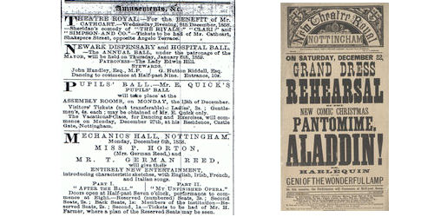

Figure 1. Examples of source material:
(a) Newspaper advertisements
(b) Playbill
Venue image
Location id
Venue open date
Image_ID

Image
Image ID
Image title
Location
Date
Credits

Production image
Venue
Production ID
Image_ID

Event - Performer
Production ID
Start date
Programme number
Person id
Role/Reading

Person ID
Surname
Firstname
Title
Amateur/prof
Role ID

Person
Production ID
Production title
Location ID
Venue open date
Amateur/Professional
Category ID
Person ID (manager)
Comments
Venue type
Venue type_ID
Venue type_name
Location_type ID
Location type name
Location type
Location
Location coordinate
Location ID
Sequence number
X-coordinate
Y-coordinate
Performance - Ticket
Production ID
Start date
Ticket type_ID
Price in pence
Ticket type
Ticket type_ID
Ticket type name
Location ID
Location name
Location open date
Location close date
Location type ID
Comments
Location id
Venue open date
Venue close date
Venue type ID
Venue name
Audience
Capacity
1851 census
Comments
Production ID
Start date
End date
Transport
Audience
Ticket availability
Price
Patron name
Comments
Production category
Category ID
Category name

Production
Performance
Production ID
Start date
Programme number
Event title

Event

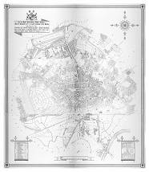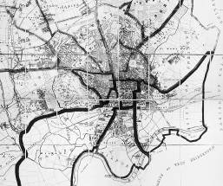

Figure 3. Map data used, 1861 (left) and 1877 (right)
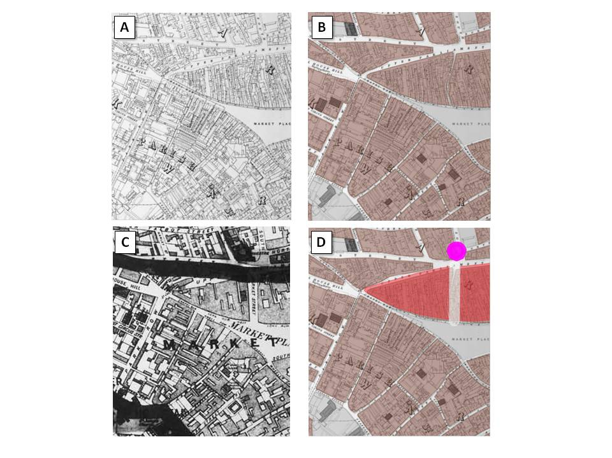

Figure 4. The production of generalised map overlays

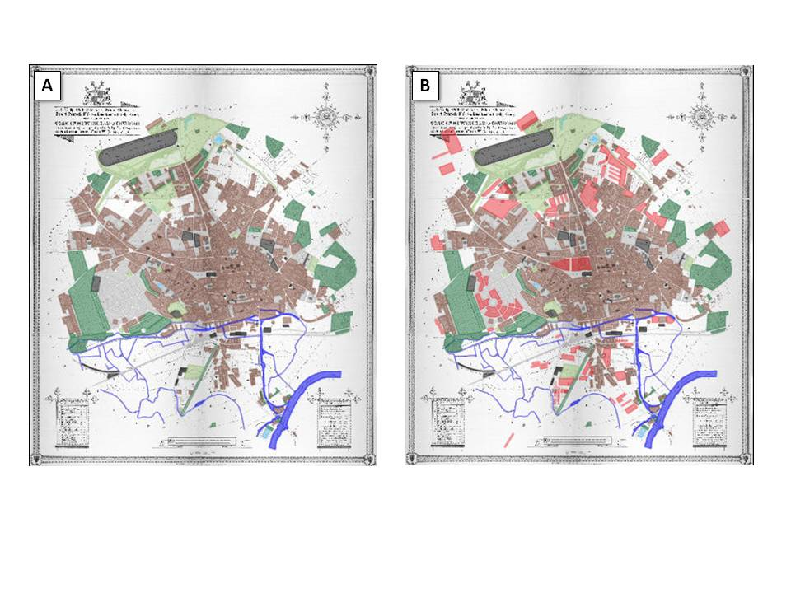Figure 5. The generalised map overlays for the start and end of the project period

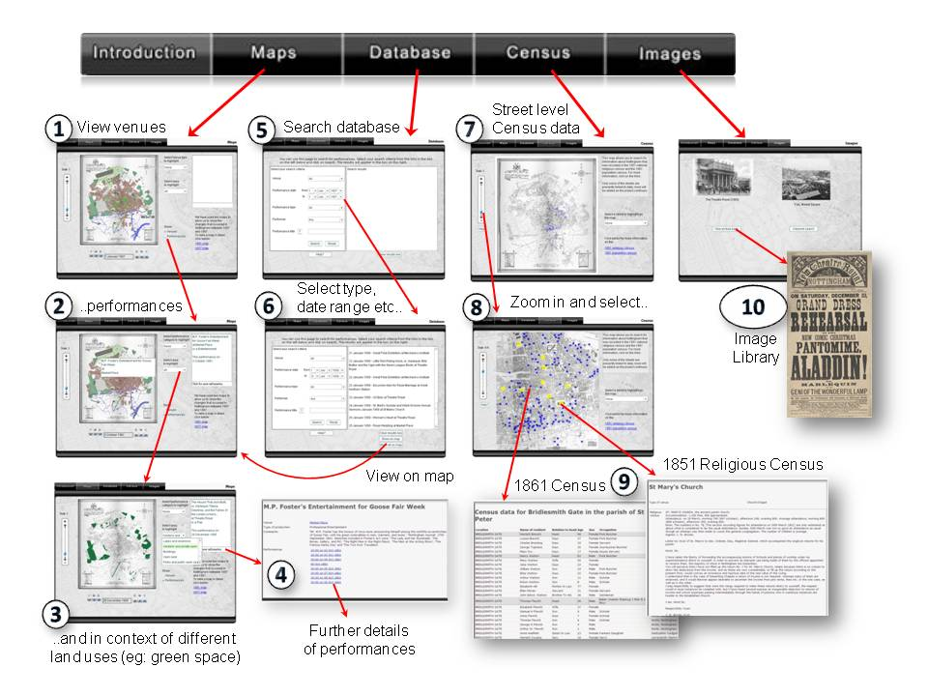
Figure 6. Flow diagram for the application user interface
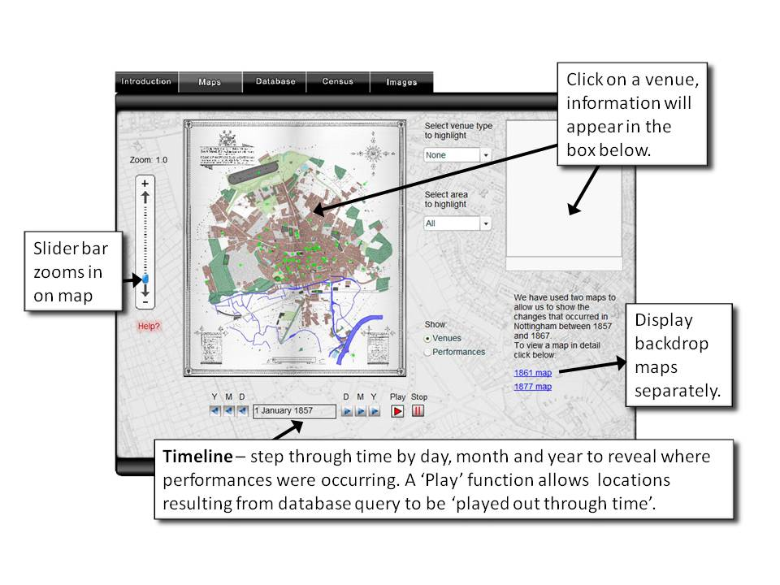
Figure 7. The main map interface
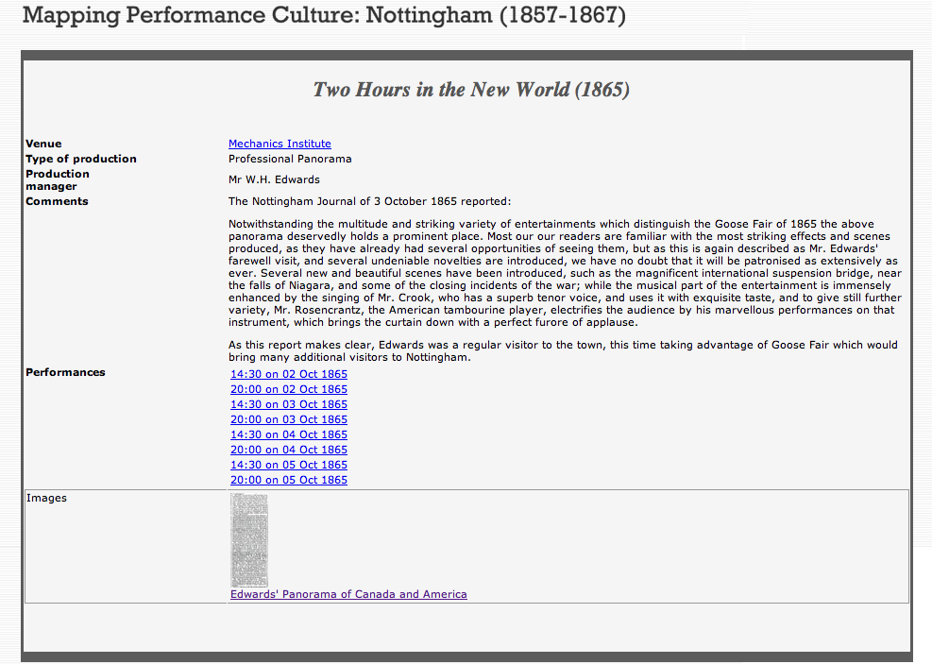
Figure 8. Details of performance, ‘Two Hours in the New World’

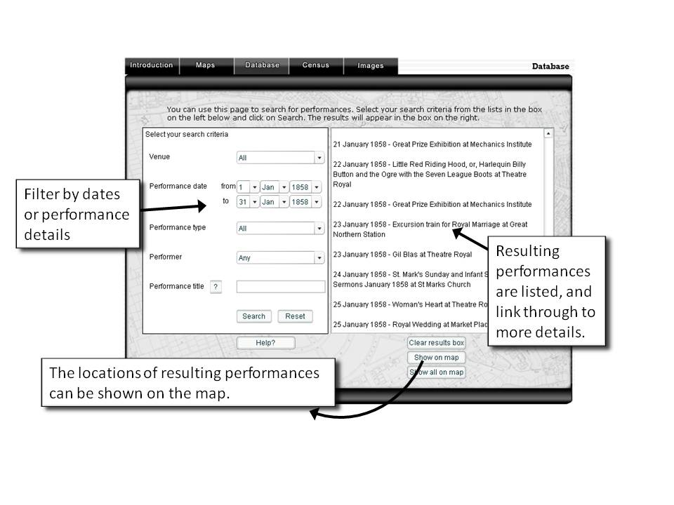
Figure 9. Querying the database by attribute
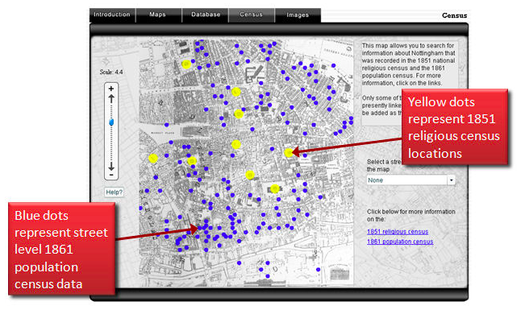
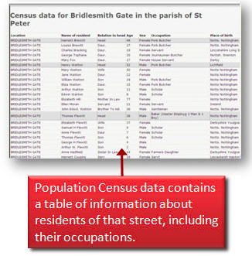

Figure 10. The census map
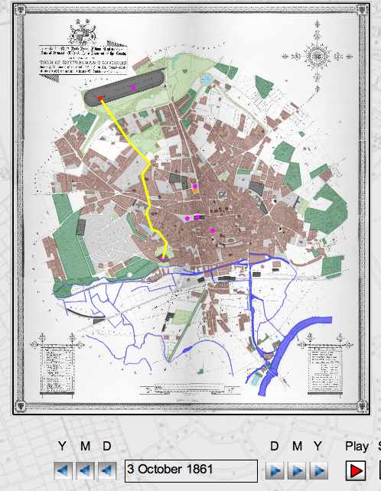
Figure 11. Route of the parade of the Robin Hood Rifles during Goose Fair 1861

For further information on the AHRC, please see www.ahrc.ac.uk. We should also acknowledge: Elaine Watts from the cartographic unit in the School of Geography, the University of Nottingham for the production of the generalised map overlays; Dr Lucie Sutherland; Nottingham City Libraries; Nottinghamshire County Archives; Manuscripts and Special Collections team at Nottingham University.
As ever, when attempting to capture the popular, there are inevitable omissions: events not advertised, reported on or written about in the diaries of Nottingham’s middle class citizens.
Joseph Donohue, ‘Evidence and Documentation’, in Interpreting the Theatrical Past: Essays in the Historiography of Performance, ed. by Thomas Postlewait and Bruce A. McConachie (Iowa, 1989), pp. 177-97 (p. 189).
Michael Booth, Theatre in the Victorian Age (Cambridge, 1991), p. 10.
Jacky Bratton, ‘Reading the Intertheatrical, or, the Mysterious Disappearance of Susannah Centlivre’, in Women, Theatre and Performance: New Histories, New Historiographies, ed. by Maggie B. Gale and Viv Gardner (Manchester, 2001), pp. 7-24 (p. 15).
The number of excursionists arriving by rail were counted at 38,000 by the Nottingham Journal, 5 October 1865.
Nottingham Journal, 5 October 1865.
Users are also able to access images of both the original scans as separate entities from the main Maps tab of the site.
Black writes that ‘it is necessary to reconstruct and understand past geographies with reference to the attitudes of the period; the meanings of location, distance, proximity, space and territory explain the spatial context of a given subject and period and cannot be assumed in modern terms’. Maps and History: Constructing Images of the Past (New Haven and London, 1997), p. 238.
Each performance is created as an object (Flash movie) for display on the map. Those performances occurring on the first day of the study period are displayed initially; all the other performances are initially set to be invisible. When a new date is selected the application parses through all the performance movies and sets to visible those that occur on the new date and invisible those occurring on any other date.
Ian Gregory, ‘Using Geographical Information Systems to explore space and time in the humanities’, in Mark Greengrass and Laura Hughes, eds, The Virtual Representation of the Past (Farnham, 2008), pp. 135-46, p. 142.
Dr Lucie Sutherland, post-doctoral researcher on the Mapping the Moment project, has written on the activities of the Robin Hood Rifles: see ‘Mapping the Robin Hood Rifles in mid-nineteenth century Nottingham’, forthcoming.
See Mapping Medieval Chester: place and identity in an English borderland city c.1200-1500, http://www.medievalchester.ac.uk.

