‘All symptoms are a kind of geography; they take a person in certain directions, to certain places and not to others. (Phillips, 2001. p.136)

An Introduction to the Wasteland Twinning Network

Introduction
Wasteland Twinning is an ongoing international research network exploring the identity, value and future use of inner-city wastelands. Wasteland Twinning hijacks the concept of ‘city twinning’ and applies it to urban wastelands in order to question perceived values in relation to land use. Since 2010 a growing number of artists and practice-based researchers, known collectively as explorers, have in various ways attempted to gain a deeper understanding of their adopted wasteland sites. These wastelands have been linked through creative activity, research and events coordinated and documented through the website http://wasteland-twinning.net/. Wasteland Twinning is continually in development, it has no fixed time frame or membership and its direction and purpose are constantly evolving. As one of the founding members of the project, I would like to critically reflect on the journey made so far, opening up some of the complex challenges and contradictions encountered along the way. My intention is to introduce the Wasteland Twinning Network and to consider the purpose, impact and meaning of the many activities that have taken place under its auspices.
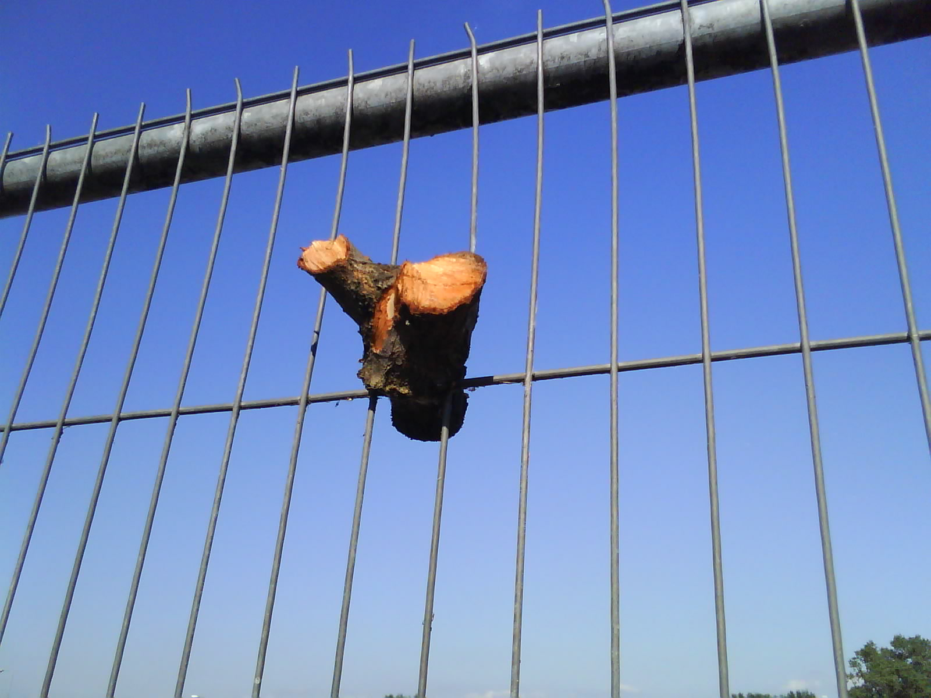
Herras fencing removed from wasteland in Glasgow. (2010) Image copyright Justin Carter.

Background
The Wasteland Twinning network began in 2010 following discussions between artists Will Foster, Matthias Einhoff, Lars Heyer and myself. A mutual fascination for urban wastelands and a recognition of their creative potential is what brought us together. Our first meeting took place in Berlin, overlooking a vast area of derelict land which had been established and maintained since 2006 as Skulpturenpark Zentrum by the art collective KUNSTrePUBLIC. With this model of practice forming the backdrop, we discussed what the Wasteland Twinning network might become. Would anyone else be interested in joining us, and if so, how would we meet? Emerging aims of the project included a desire to share research methods and to question urban land use policy and practice by bringing wasteland sites into critical, creative and cross-cultural focus.

Since 2010 Wasteland Twinning has grown to incorporate twenty different sites in fourteen different countries in four different continents. It has linked thirty-four explorers through twenty-three different research methods, resulting in numerous different projects - including exhibitions and seminars and one major forum that took place in September 2013. None of this would have been possible without the Wasteland Twinning website which has served as a communication conduit within the network. The online documentation archived within the website has subsequently become a major public interface, disseminating a substantial body of research to a large public audience. To some extent, the Wasteland Twinning website has succeeded in creating a cohesive identity to what could otherwise be described as an unwieldy and uncertain entity.

Social Spaces
Despite its somewhat disparate character, one fairly consistent drive to have emerged from a large number of activities within the network is that of social engagement. Although it was never an explicit aim, social interaction has come to define many of the activities that have taken place so far. Often social gatherings of various kinds have been orchestrated within the wasteland sites themselves. If wastelands represent the abandoned ruins of boom and bust development, it seems that Wasteland Twinning has granted permission for the public to access these spaces once again, doing so in a convivial, sometimes playful atmosphere.

This social focus is due - at least in part - to the essence of what wastelands represent in cultural terms: They are a kind of no-mans land, cut-off either physically or psychologically. They are essentially anti-social. Evidence of impromptu homeless shelters in Glasgow’s wastelands or semi-permanent dwellings on wastelands in Yogyakarta, Indonesia don’t contradict this notion so much as evidence the way in which various social groups are pushed to the margins.

In a misanthropic sense then, wastelands are wild. But desolate wildness is not the same thing as nature. Even though biodiversity might re-establish itself at tremendous speed against a backdrop of culture and industrialization, we should avoid the temptation of seeing wastelands as romantic spaces. In their book Edgelands – Journeys Into Englands True Wilderness, Paul Farley and Michael Symmons-Roberts occasionally fall into this trap:

‘It’s always a surprise, walking along a busy city street, to find a gap in the shiny advertising hoardings or a bent-back sheet of corrugated iron which affords a view on to an open wasteland carpeted with flowers in summer, or the archaeological earthworks of new building work where foundations are being laid. The city, suddenly, has a new scale, an underness and overness, and the eye, having scarcely a moment to readjust from the enclosing streets and buildings, is overwhelmed. The journey to a high moor or heath in search of wilderness and communion with nature involves a slow readjustment in terms of scale and space, but a city wasteland is all the more mysterious for the manner of our encounter with it: the imagination does the travelling’. (Farley & Symmons Roberts, 2012. p.137)

In his review of Edgelands, Robert Macfarlane criticizes Farley and Symmons-Roberts for their underlying suggestion that ‘wasteland is paradise’. Even Richard Mabey in his classic wasteland study, The Unofficial Countryside, slips into this romantic notion of seeing wastelands as nature spaces that are separate from, in which we escape to:

‘Of course I was not really lost. If I had walked a straight quarter-of-a-mile in any direction I could not have failed to strike a road, or at least a well-used path. But the illusion was there. I could see and hear not a single human sound. I had no idea what lay in front of me, nor the direction I ought to take to get out’.
(Mabey, 1973. p.144)

Despite the way in which wastelands are often presented to us as segregated plots of land, neatly parceled off by developers, we should continue to recognize them as landscape – part of a continuum, not as some kind of rarified nature exhibit. Tim Ingolds understanding of environment is helpful in this respect. He states that:

‘(Environment) should on no account be confused with the concept of nature. For the world can exist as nature only for a being that does not belong there, and that can look upon it, in the manner of the detached scientist, from such a safe distance that it is easy to connive in the illusion that it is unaffected by his presence. Thus the distinction between environment and nature corresponds to the difference in perspective between seeing ourselves as beings within a world and as beings without it’. (Tim Ingold, 2000. p.18)

Herein lies the wasteland paradox: Wastelands become characterized as nature spaces because, in the urban context they become disconnected and objectified. This perception is further accentuated by the trend for contractors to leave windows in the hoardings surrounding such sites, exaggerating this sense of unreality – landscape as picture, held at a distance. However, wastelands do not constitute some kind of ubiquitous nature returning to the city. Instead, they should be understood as a series of very distinct environments, each with it’s own history created through the interaction of people and place. Without experience of, or interaction with landscape, there can be no sense of belonging, only ownership in legal or monetary terms.

Perhaps subconsciously this understanding has been at the heart of Wasteland Twinning – a politics that strives to engage people in the process of re-defining these spaces. Many explorers have questioned the stereotype of wastelands as unused spaces, inventing research methods that make visible these hidden uses. Often these have unearthed the environmental significance of urban wastelands. Other examples have demonstrated the way wastelands already form part of an existing social tapestry incorporating the likes of dog walkers, urban ramblers, foragers and temporary dwellers. Through the various events and activities initiated through the network, Wasteland Twinning has also suggested various new possibilities connecting people with place. Beyond the twinning ceremonies themselves, a good example of this is The Games - a faux Olympics, acted out on the Kopi Brache wasteland in Berlin (2012).

However, three ongoing questions arise from these activities:

- First of all, who exactly are these people connecting with landscape? Is it just a select group of ‘artistic nomads’ (as Hal Foster might call us) wading in from outside, having a conversation with ourselves?
- Secondly, if the Wasteland Twinning network chooses to accept funding from various agencies and official bodies (as it has done), does it somehow lose its capacity to think and act independently, in critical mode?
- Finally, if Wasteland Twinning activity fails to offer a sustainable future for these sites, does it in fact play into the hands of developers, creating for them a unique ‘gift-wrap’ service where parcels of land can be sold to the highest bidder? Are explorers the human equivalent of the pioneering plant, heralding a succession of economic development that will inevitably result in further disruption and social rupture?

In exploring the future potential of wastelands, these questions might provide useful touchstones for the Wasteland Twinning network to engage with. They might also resonate with other researchers and creative practitioners focusing on similar landscape issues.

Conclusion
Wasteland Twinning is by no means unique as an example of practitioners and researchers exploring the creative potential of urban wastelands. In fact, there is evidence to suggest that Wasteland Twinning is part of a growing trend. In a Guardian article from 2010 entitled In the gaps developers left, another world is being built, Andy Beckett writing about various creative initiatives throughout the United Kingdom commented that:

‘We have a limited amount of countryside and indifferent weather, so there is only so much mileage in our natural sublime. It is in the built environment that much of our potential lies’. (Beckett, 2010. p.30)

Urban wastelands will continue to perplex and fascinate in equal measure because unlike so much of our urban environment, it’s meaning, value and use is continually in flux. As ever-increasing amounts of public space fall into private ownership – where access and use are prescribed, wastelands offer a welcome opportunity to play, to re-imagine and be challenged by a complex environment harboring contradictions and uncertainty. Within this landscape the Wasteland Twinning network hopefully provides a signpost suggesting a continued ‘right to roam’:

References:

Beckett, Andy. (21/8/2010) In the gaps developers left, another world is being built. The Guardian.

Farley, P and Symmons Roberts, M. (2012) Edgelands – Journeys Into Englands True Wilderness. Vintage.

Foley, Michael. (2013) Life Lessons from Bergson. Pan Macmillan.

Ingold, T. (2000) The Perception of the Environment. Routledge.

KUNSTrePUBLIC, Skulpturenpark Berlin_Zentrum. (2010) Verlag der Buchhandlung Walter Konig, Koln.

Kwon M. (2002) One Place After Another – Site-Specific Art and Locational Identity. MIT Press.

Mabey, Richard. (1973) The Unofficial Countryside. Little Toller Books.

Macfarlane, Robert. (19/2/11) Over the Edge. p.8, Guardian.

Phillips, A. (2001) Houdinis Box – On the Arts of Escape. Faber and Faber.

Woods, L. (2000) No-mans’s land. Taken from Architecturally Speaking ed. Alan Reid, Routledge,

Justin Carter
Researcher and Lecturer
Sculpture & Environmental Art Department (SEA)
Glasgow School of Art
9-11 West Graham Street
Garnethill
Glasgow

T (0141) 353 4797
M 07790638751
j.carter@gsa.ac.uk

This proposed paper/presentation relates to:
1. The Urban Wild

The name ‘explorer’ is given to those who join the network through the Wasteland Twinning website.
The website is constructed and maintained by Lars Heyer.
Matthias Einhoff, Philip Horst, Markus Lohmann, Harry Sachs and Daniel Seiple are KUNSTrePUBLIC.
Miwon Kwon quoting Hal Foster. (2002) p.138.

