MEMORY LAUNDRETTE: ELEMENT 1, PULLEY–WORK IN PROGRESS

Authors:
THOMAI PNEVMONIDOU, PATRICK MACKLIN

Affiliation:
THE GLASGOW SCHOOL OF ART, SCOTLAND, UK

INTRODUCTION
Memory Laundrette is a project which seeks to develop an approach to the design of critical vectors within the built environment. With a particular focus on interiors in urban settings, it employs genius loci to create platforms from which to explore the potential of non-linear approaches to the creation of artefacts. These complex and layered objects serve in turn as conduits for broader discussion on the role of design in the shaping of urban space, incorporating the enduring impact of the layered legacies of (in particular) utopian modernism and offering potential future alternatives. By introducing a type of dematerialised making into the post facto production of, in this instance, utilitarian objects, the inquiry looks at how design fictions and telematic-crafting might be used as threshold crossing devices oscillating between memory, craft, design and production with the ambition to create speculative props as a part of the intangible heritage that, for now, is the performed aspects of laundering clothes.
The impulse to develop a process in this way emerged from an earlier study¹ exploring the nature of high-density dwelling expressed in the form of the Victorian tenement and the mid-twentieth century tower block.² This utilised partial and autobiographical approaches to layered and complex content, drawing on both archival and anecdotal elements of a specific built environment, to reassert the essence of that which had been lost or forgotten (principally through demolition), and that which had been recovered (through adaptation). This was further developed in a subsequent consideration of contemporary ways of living through spectral recollections, ficto-critical writing, or science fiction prototyping, with an emphasis placed on the rituals of everyday life and how directly they are intertwined with spatial memories, whether explicit, implied, or fading. It asked how we – through carefully revealing the components of such scenography, and its assembly – might develop a more resilient form and object, less burdened by conventional materiality and the direct shaping of stuff.³

SOAK & SCRUB
The point of departure is via a pair of related artefacts once commonplace in the domestic urban settings of the city of Glasgow, Scotland, and the city-state of Singapore. These are the pulley: a mechanical system of blocks, laths, sash-cords, and lift-frames found attached to the high kitchen ceilings of Victorian tenements in Glasgow, and the tek-koh: a bamboo clothes drying pole, socket-mounted on the exterior of early examples of Housing Development Board (HDB) buildings in Singapore. The pulley and the tek-koh are ordinary household effects, hidden in plain sight, the former above eye level indoors, the latter on the physical exterior of their host building. These utilitarian, quietly emblematic objects, were used in the laundering and airing of clothing and cloth. In each case, when active they are shrouded in fabric and when inactive they are exposed as mere unadorned mechanical devices, miscellaneous objects⁴ made for frequent, and unglamorous utility.
In Britain, the pulley system was refined and commercialised in the nineteenth century during which time kitchens might have been considered incomplete without a clothes-airer of this type. The cast-iron lift frames were available in a range of colours and sizes and carried parallel rows of timber laths in configurations of usually four to eight. The room where they were tactically positioned possessed ‘ritualistic qualities’⁵ as well as representing the core of the household where the family would spend most of its time–in some instances this was the only option as it was the only room, it contained a bed recess and toilets were external to the dwelling. Despite this the sense of domesticity, even cosiness, condensed a sense of homeliness. ‘In most apartments the kitchen was no more than a pot hanging in the fireplace’⁶ however in the typical Glaswegian tenement the kitchen was the most important room, where all this ‘specialized domestic work–women’s work’ took place.⁷ It was also, eventually, the place where the range or oven was located and therefor logical to hang the pulley there to draw from rising warm air currents generated from the fireplace and the cooking range itself.

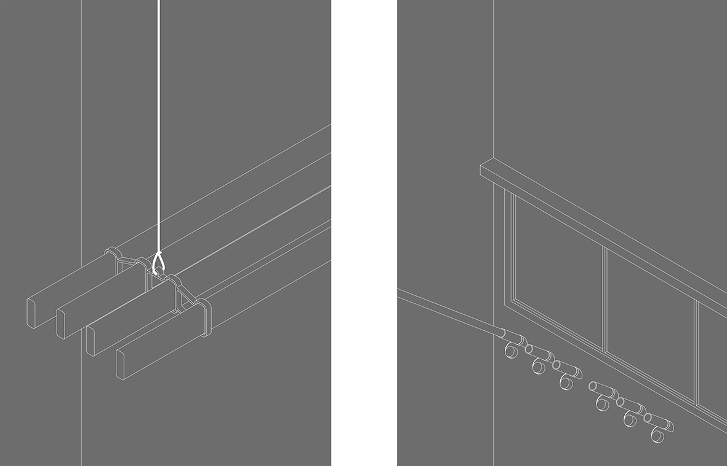

Figure 1. Pulley and Tek-Koh, artwork for diptych

RINSE & WRING
Memory Laundrette folds-in matters concerning the relationship and interdependence between the senses. The kitchen is transformed into a ‘multi-sensory context’⁸ and captures the essence of domestic identity, cultural identity, and habitual, ritualised living. Laundering clothes has a very particular tactility. Freshly cleaned garments and cloth, when positioned on an airer, are cold and damp to the touch as well as heavy to lift. They may also be fragrant, but their moisture content suppresses free movement of scents. Once the transformative process of drying has concluded they are crisp and soft, significantly lighter, and more airily perfumed. By exploring the ‘technologies of washing, drying, and ironing, to soaps and detergents’⁹ an invisible essential part of the object significance becomes central. Moreover, the subtleties of a hierarchy of engagement with such stimuli emerges too. ‘Smell and texture are relevant, but freshness is in essence a state of mind’.¹⁰ The combination of visual, physical, and olfactory experience, ‘I can smell cleanliness, it is inevitable’,¹¹ offers a fresh perspective on potential reproduction or collaging of the object itself and importantly, how it relates to its spatial setting and the myriad activities and interactions contained within that context. ‘It takes a little more imagination no doubt to picture an apartment whose layout was based on the functioning of the senses’.¹²

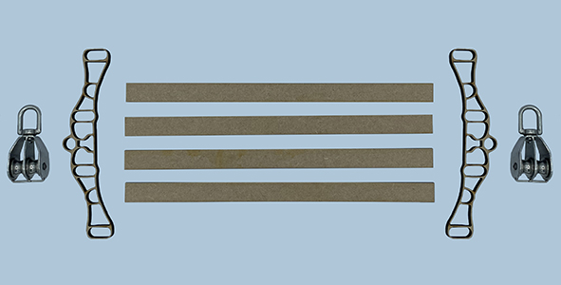

Figure 2. Deconstructed Pulley, 1:2 scale, ready-made blocks, additive printed frames and laser-cut lath

Our attempt to reconstruct the pulley incorporated considerations of laundering processes¹³ and the spectacular nature of the hoisting of the washing load when positioned on the respective devices. The work is also supplemented by our existing knowledge and experience in using the pulley system. These moments were used as indicators of the memories embedded in the apparatus and represent new layers in its narrative. Where, once upon a time, speculations on the nature of the beauty of a useful object concluded that it can only be explained in terms of its purpose¹⁴ we are drawn instead to treating each stage of the development process as iterative. The resulting objects perform as a type of three-dimensional palimpsest. Enabled by the capacity of those contemporary materials and processes deployed in digitised batch-production it is possible to accrue traces of the atmosphere of domesticity and the acknowledgement of superfluous attributes. While Victorian innovation sought ways to employ technical devices that would facilitate everyday living, we were unburdened by such concerns, instead our method of counterfeiting preferred to exploit the rapid capacity of contemporary methods of fabrication to create light-touch prototypes in materials with no subsequent practical duties to perform. ‘Working practically with materials offered a more powerful procedure of discovery’.¹⁵ The crafting process was informed by digital representations and digital crafting. We first focused on the visual presentation of the idealised formal arrangement of the objects and included chroma, materiality, texture, and weight. In some instances, this was a repetitive process, requiring detailing and acknowledgment of material performance, such as the load bearing capacity of fixed elements such as the framing or moving parts, such as the cord and blocks. We then introduced motion and by extension mechanical or physical detail relevant to wall or ceiling mounting. These decorative, even beautiful objects are kinetic at their core. We preserved their form and basic components, and sampled colour, pattern and texture with the aim of enhancing their legibility. To achieve a better understanding of the essence of the object it was recreated in digital form and 3D printed. The process enabled refreshing of historical and contextual meaning and the manifestation of revived objects with the opportunity to speculate on their future interdependence (as a collection of parts, and as an object inhabiting particular space). Machines produce artefacts that are cold and shallow,¹⁶ removing hand skills or the joy from the creator. Conversely, dissolving the division between physical and digital production is a reality of contemporary practice, from LIDAR harvesting of point-cloud data through to lightweight robotic printing of mud to form inhabitable spaces such as Emerging Objects’ ‘Casa Covida’ and viewing digital fabrication as an enhancement of spatial, bodily and object relationships provide an opportunity for advanced interdisciplinary research.¹⁷ In our case the rudimentary nature of the components involved enabled us to rapidly experiment with distanced fabrication and open possibilities from within the salvaged fragments of each source piece, for the incorporation of additional, non-visual, interactive, temporal elements. This latter opportunity assists with articulating aspects of the interdependency of the drying device on the cloth itself, such as the impact felt, after the introduction of cotton textiles garments, on a significant scale, as a readily ‘washable’ fabric, on those people, usually women, responsible for that task.¹⁸

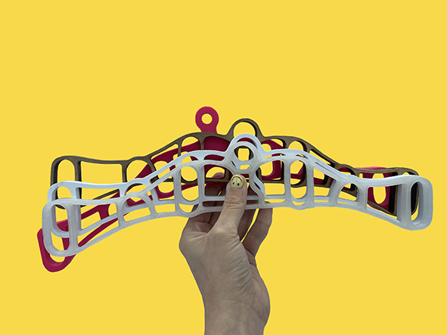

Figure 3. Selection of pulley frames, scaled and digitally produced prototypes

DRAPE & AIR
The high contrast nature of the internal and external airing of garments in each geographical, planned and crafted setting–those of north western Europe and south east Asia–serves as a useful and spectacular case-study for the next step in our niche inhabitation of a type of comparative urbanism. In transitioning towards ‘Memory Laundrette: Element 2, Tek Koh–Work in Progress’ the verticality of the Singaporean context takes our exploration into the intense dynamic of a multi-nodal external proximity of clustered clothing, linens and drapes, all, importantly, on public display, however the introspective setting of the tenement draws matters of interiority, intimacy and proximity into orbit, and yet negates any easy binary reading of things, in part due to the limitations and capabilities of the materiality of the respective host building constructions – stone and timber alongside steel and concrete – this drops dizzying perspectival buffers into the mix. Thirty plus floors of externally displayed items made abstract by distance, alongside the intimacy of kitchen spaces, enclosed and heated, entered by invitation only, with similar stuff, hoisted and tethered to the ceiling, a domestic variation of the theatrical fly system. Meanwhile, the jumbled, kaleidoscopic vortex of the spin-dryer lurks in the wings, obscene.

PRESS & FOLD
The process of laundering is a convergence of diverse components – textiles, equipment, sound, scent, and motion, all within particular scenographic configurations with human agency in operation. We seek to incorporate olfactory and interactively triggered dynamic responses within the physicality of the apparatus of the pulley and tek-koh, and their symbiotic relationship to their architectural and urban contexts. Historically gendered associations with domestic tasks and cleanliness¹⁹ led us to consider embedding biased face recognition tracking software to directly influence the motion of each airing frame. Information regarding stresses on the slats, rods and sockets, might be relayed through sensor-relay. Finally, we have discussed how sound can enhance the experience and the object performance. This would involve pre-recorded material for interviews or sound form current technologies of washing hoping to achieve an evocative experience. As Memory Laundrette develops, we seek to augment readings of place, interior(s) and architecture(s), through reshaping of once ubiquitous but now relegated, utilitarian objects grafted into fresh contexts.²⁰

NOTES

¹ Patrick Macklin. “Some Places Where I Spent Some Time.” Interiors Design Architecture and Culture 8 (1–2), (2017): 67–71.
² Patrick Macklin. “Aural Utopia.” Interiors Futures Crucible Press, California, (2019): 46–54.
³ The tone of the reference to the object is best articulated via this word. For elegant use see Daniel Miller, Stuff, especially the introductory section.
⁴ See, Soetsu Yanagi. The Beauty of Everyday Things, trans Michael Brase. London, England: Penguin Classics, 2019.
⁵ Graeme Brooker and Lois Weinthal, eds. The Handbook of Interior Architecture and Design (London, England: Bloomsbury Academic, 2017), 42.
⁶ Witold Rybczynski. Home (New York, NY: Pocket Books, 2001), 73.
⁷ Witold Rybczynski. Home (New York, NY: Pocket Books, 2001), 70.
⁸ Sarah Pink. Home Truths: Gender, Domestic Objects and Everyday Life (London, England: Berg, 2004), 33.
⁹ Elizabeth Shove. Comfort, Cleanliness and Convenience: The Social Organization of Normality. (Oxford, England: Berg 2003), 19.
¹⁰ Elizabeth Shove. Comfort, Cleanliness and Convenience: The Social Organization of Normality. (Oxford, England: Berg 2003), 402.
¹¹ Sarah Pink. Home Truths: Gender, Domestic Objects and Everyday Life (London, England: Berg, 2004), 68.
¹² Georges Perec. Species of Spaces and Other Pieces (London, England: Penguin Classics, 2008), 31.
¹³ Fintan O’Toole. We Don’t Know Ourselves: A Personal History of Ireland since 1958 (London, England: Head of Zeus, 2022), 61, closing section of Chapter 3, 1960: Comanche Country, 53-63)
¹⁴ Adolf Loos. Ornament and Crime (London, England: Penguin Classics, 2019).
¹⁵ Tim Ingold. Materials against Materiality, Archaeological Dialogues 14 (1) (Cambridge University Press, 2007),
¹⁶ Soetsu Yanagi. The Beauty of Everyday Things. Translated by Michael Brase (London, England: Penguin Classics, 2019).
¹⁷ Jonathon Anderson and Lois Weinthal. Digital Fabrication in Interior Design: Body, Object, Enclosure (New York: Routledge, 2021). (Chapter 9, The role of the Hand in Digital Design, 125-137)
¹⁸ Ruth Schwartz Cowan. More Work for Mother: Ironies of Household Technology from the Open Hearth to the Microwave. (London, England: Free Association Books, 1989). Closing section of Chapter 4, The Invention of Housework: The Early Stages of Industrialization: More Chores for Women, Fewer for Men, 63-68
¹⁹ Sarah Pink. Home Truths: Gender, Domestic Objects and Everyday Life (London, England: Berg, 2004).
²⁰ Development of the tek-koh component was tied into pre-pandemic academic partnership work in Singapore. Restrictions surrounding COVID-19 resulted in a decision to suspended work on this part (Element 2) of the project. This is now set to resume.

BIBLIOGRAPHY

Anderson, Jonathon, and Lois Weinthal. Digital Fabrication in Interior Design: Body, Object, Enclosure. New York: Routledge, 2021.
Brooker, Graeme, and Lois Weinthal, eds. 2017. The Handbook of Interior Architecture and Design. London, England: Bloomsbury Academic.
Chee, Lilian and Melany Sun-Min Park. Home+Bound: Narratives of Domesticity in Singapore and Beyond. Singapore: CASA–ARMs, 2013.
Cowan, Ruth Schwartz. More Work for Mother: Ironies of Household Technology from the Open Hearth to the Microwave. London, England: Free Association Books, 1989.
De Grazia, Victoria, and Ellen Furlough, eds. The Sex of Things: Gender and Consumption in Historical Perspective. Berkeley, CA: University of California Press, 1996.
Dunne, Anthony, and Fiona Raby. Speculative Everything: Design, Fiction, and Social Dreaming. London, England: MIT Press, 2013.
Farr, Ian, ed. Memory. London, England: MIT Press, 2012.
Harrod, Tanya. Craft. Edited by Tanya Harrod. London, England: MIT Press, 2020.
Ingold, Tim. Making: Anthropology, Archaeology, Art and Architecture. London, England: Routledge, 2013.
Ingold, Tim. ‘Materials against Materiality’, Archaeological Dialogues 14 (1), 2007.
Lange-Berndt, Petra, and Iwona Blazwick, eds. Materiality. London, England: MIT Press, 2015.
Lefebvre, Henri. The Missing Pieces. Translated by David L. Sweet. Brooklyn, NY: Semiotext (E), 2014.
Loos, Adolf. Ornament and Crime. London, England: Penguin Classics, 2019.
Macklin, Patrick. ‘Some Places Where I Spent Some Time’, Interiors Design Architecture and Culture 8 (1–2), (2017): 67–71.
Macklin, Patrick. 'Aural Utopia’. Interiors Futures Crucible Press, California, (2019): 46–54.
Miller, Daniel. Stuff. 1st ed. Oxford, England: Polity Press, 2013.
Miller, Daniel. Materiality. Durham and London, England: Duke University Press, 2005.
O’Toole, Fintan. We Don’t Know Ourselves: A Personal History of Ireland since 1958. London, England: Head of Zeus, 2022.
Perec, Georges. 2008. Species of Spaces and Other Pieces. London, England: Penguin Classics.
Pink, Sarah. Home Truths: Gender, Domestic Objects and Everyday Life. London, England: Berg, 2004.
Rybczynski, Witold. Home. New York, NY: Pocket Books, 2001.Sennett, Richard. The Craftsman. Harlow, England: Penguin Books, 2009.
Shove, Elizabeth. 2003. Comfort, Cleanliness and Convenience: The Social Organization of Normality. Oxford, England: Berg.
Space Caviar, ed. SQM the Quantified Home: An Exploration of the Evolving Identity of the Home, from Utopian Experiment to Factory of Data. Baden, Switzerland: Lars Muller, 2014.
Tally, Robert T. Spatiality. London, England: Routledge, 2013.
Trentmann, Frank. Empire of Things: How We Became a World of Consumers, from the Fifteenth Century to the Twenty-First. Harlow, England: Penguin Books, 2017.
Weinthal, Lois. Toward a New Interior: An Anthology of Interior Design Theory. New York, NY: Princeton Architectural Press. 2011.
Yanagi, Soetsu. The Beauty of Everyday Things. Translated by Michael Brase. London, England: Penguin Classics, 2019.

